UNITED STATES
SECURITIES AND EXCHANGE COMMISSION
Washington, D.C. 20549
_____________

FORM 8-K
CURRENT REPORT
PURSUANT TO SECTION 13 OR 15(d) OF THE
SECURITIES EXCHANGE ACT OF 1934
Date of Report (Date of earliest event reported): July 21, 2026
Amalgamated Financial Corp.
(Exact name of registrant as specified in its charter)
Delaware |  |  |  |  |  | 001-40136 |  |  |  |  |  | 85-2757101
(State or other jurisdiction  of incorporation) |  |  |  |  |  | (Commission File Number) |  |  |  |  |  | (I.R.S. Employer Identification  No.)
275 Seventh Avenue, New York, New York 10001
(Address of principal executive offices) (Zip Code)
Registrant’s telephone number, including area code: (212) 895-8988
Not Applicable
(Former name or former address, if changed since last report)
Check the appropriate box below if the Form 8-K filing is intended to simultaneously satisfy the filing obligation of the registrant under any of the following provisions (see General Instruction A.2. below):
☐ Written communications pursuant to Rule 425 under the Securities Act (17 CFR 230.425)
☐ Soliciting material pursuant to Rule 14a-12 under the Exchange Act (17 CFR 240.14a-12)
☐ Pre-commencement communications pursuant to Rule 14d-2(b) under the Exchange Act (17 CFR 240.14d-2(b))
☐ Pre-commencement communications pursuant to Rule 13e-4(c) under the Exchange Act (17 CFR 240.13e-4(c))

Securities registered pursuant to Section 12(b) of the Act:
Title of each class |  |  | Trading Symbol(s) |  |  | Name of each exchange on which registered
Common Stock, par value $0.01 per share |  |  | AMAL |  |  | The Nasdaq Global Market

Indicate by check mark whether the registrant is an emerging growth company as defined in Rule 405 of the Securities Act of 1933 (17 CFR § 230.405) or Rule 12b-2 of the Securities Exchange Act of 1934 (17 CFR § 240.12b-2).

Emerging growth company ☐

If an emerging growth company, indicate by check mark if the registrant has elected not to use the extended transition period for complying with any new or revised financial accounting standards provided pursuant to Section 13(a) of the Exchange Act. ☐

Item 7.01. Regulation FD Disclosure.

On July 21, 2026, Amalgamated Financial Corp. (the "Company") issued a press release announcing that the Board of Directors declared a quarterly dividend of $0.17 per share. The dividend is payable on August 20, 2026, to shareholders of record on August 4, 2026. A copy of the press release is furnished as Exhibit 99.1 to this Current Report Form 8-K and is incorporated by reference herein.

Item 9.01 Financial Statements and Exhibits.

(d) Exhibits The following exhibit index lists the exhibits that are either filed or furnished with this Current Report on Form 8-K:

EXHIBIT INDEX

Exhibit No. |  |  | Description
99.1 |  |  | Press Release dated July 21, 2026
104 |  |  | The cover page from this Current Report on Form 8-K, formatted in Inline XBRL.

SIGNATURES
Pursuant to the requirements of the Securities Exchange Act of 1934, the registrant has duly caused this report to be signed on its behalf by the undersigned hereunto duly authorized.

 |  |  |  |  |  | AMALGAMATED FINANCIAL CORP.
 |  |  |  |  |  | By: |  |  | /s/ Priscilla Sims Brown
 |  |  |  |  |  | Name: |  |  | Priscilla Sims Brown
 |  |  |  |  |  | Title: |  |  | Chief Executive Officer
Date: July 21, 2026
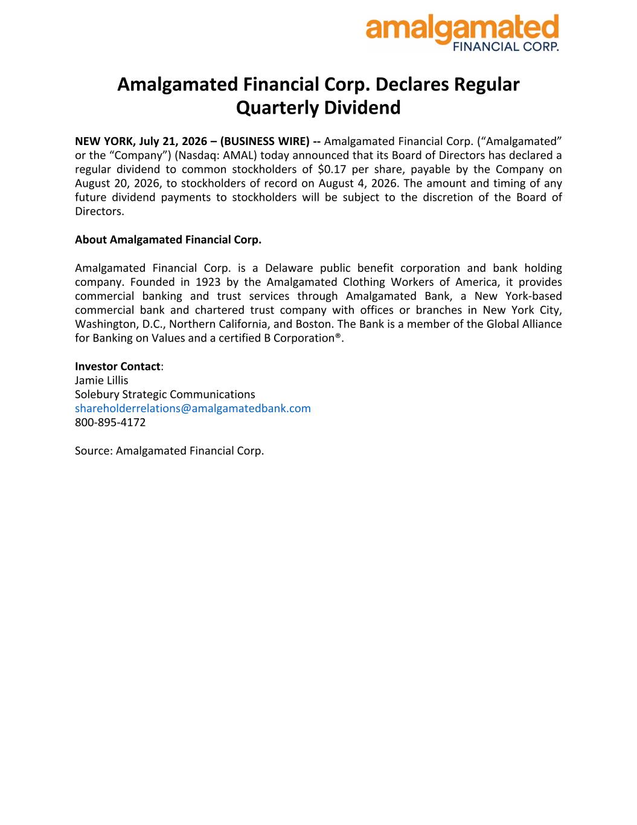

Amalgamated Financial Corp. Declares Regular Quarterly Dividend NEW YORK, July 21, 2026 – (BUSINESS WIRE) -- Amalgamated Financial Corp. (“Amalgamated” or the “Company”) (Nasdaq: AMAL) today announced that its Board of Directors has declared a regular dividend to common stockholders of $0.17 per share, payable by the Company on August 20, 2026, to stockholders of record on August 4, 2026. The amount and timing of any future dividend payments to stockholders will be subject to the discretion of the Board of Directors. About Amalgamated Financial Corp. Amalgamated Financial Corp. is a Delaware public benefit corporation and bank holding company. Founded in 1923 by the Amalgamated Clothing Workers of America, it provides commercial banking and trust services through Amalgamated Bank, a New York-based commercial bank and chartered trust company with offices or branches in New York City, Washington, D.C., Northern California, and Boston. The Bank is a member of the Global Alliance for Banking on Values and a certified B Corporation®. Investor Contact: Jamie Lillis Solebury Strategic Communications shareholderrelations@amalgamatedbank.com 800-895-4172 Source: Amalgamated Financial Corp.

