UNITED STATES
SECURITIES AND EXCHANGE COMMISSION
Washington, D.C. 20549
_____________

FORM 8-K
CURRENT REPORT
PURSUANT TO SECTION 13 OR 15(d) OF THE
SECURITIES EXCHANGE ACT OF 1934
Date of Report (Date of earliest event reported): July 23, 2026
Amalgamated Financial Corp.
(Exact name of registrant as specified in its charter)
Delaware |  |  |  |  |  | 001-40136 |  |  |  |  |  | 85-2757101
(State or other jurisdiction  of incorporation) |  |  |  |  |  | (Commission File Number) |  |  |  |  |  | (I.R.S. Employer Identification  No.)
275 Seventh Avenue, New York, New York 10001
(Address of principal executive offices) (Zip Code)
Registrant’s telephone number, including area code: (212) 895-8988
Not Applicable
(Former name or former address, if changed since last report)
Check the appropriate box below if the Form 8-K filing is intended to simultaneously satisfy the filing obligation of the registrant under any of the following provisions (see General Instruction A.2. below):
☐ Written communications pursuant to Rule 425 under the Securities Act (17 CFR 230.425)
☐ Soliciting material pursuant to Rule 14a-12 under the Exchange Act (17 CFR 240.14a-12)
☐ Pre-commencement communications pursuant to Rule 14d-2(b) under the Exchange Act (17 CFR 240.14d-2(b))
☐ Pre-commencement communications pursuant to Rule 13e-4(c) under the Exchange Act (17 CFR 240.13e-4(c))

Securities registered pursuant to Section 12(b) of the Act:
Title of each class |  |  | Trading Symbol(s) |  |  | Name of each exchange on which registered
Common Stock, par value $0.01 per share |  |  | AMAL |  |  | The Nasdaq Global Market

Indicate by check mark whether the registrant is an emerging growth company as defined in Rule 405 of the Securities Act of 1933 (17 CFR § 230.405) or Rule 12b-2 of the Securities Exchange Act of 1934 (17 CFR § 240.12b-2).

Emerging growth company ☐

If an emerging growth company, indicate by check mark if the registrant has elected not to use the extended transition period for complying with any new or revised financial accounting standards provided pursuant to Section 13(a) of the Exchange Act. ☐

Item 2.02 Results of Operations and Financial Condition.

On July 23, 2026, Amalgamated Financial Corp. (the "Company") issued a press release announcing financial results for the second quarter ended June 30, 2026. The press release is furnished as Exhibit 99.1 to this Current Report on Form 8-K.

The information in this Item 2.02, including Exhibit 99.1, shall not be deemed "filed" for purposes of Section 18 of the Securities Exchange Act of 1934, or otherwise subject to the liability of that section, and shall not be deemed to be incorporated by reference into any filing under the Securities Act of 1933 or the Securities Exchange Act of 1934.

Item 7.01 Regulation FD Disclosure.

On July 23, 2026, the Company will hold an earnings conference call and webcast at 11:00 a.m. (Eastern Time) to discuss financial results for the second quarter ended June 30, 2026. The press release contains information about how to access the conference call and webcast. A copy of the slide presentation to be used during the earnings call and webcast is furnished as Exhibit 99.2 to this Current Report on Form 8-K. The slide presentation is also available on our website, www.amalgamatedbank.com, under the “Investor Relations” section.

The information in this Item 7.01, including Exhibit 99.2, shall not be deemed "filed" for purposes of Section 18 of the Securities Exchange Act of 1934, or otherwise subject to the liability of that section, and shall not be deemed to be incorporated by reference into any filing under the Securities Act of 1933 or the Securities Exchange Act of 1934.

Item 9.01 Financial Statements and Exhibits

(d) Exhibits The following exhibit index lists the exhibits that are either filed or furnished with this Current Report on Form 8-K:
EXHIBIT INDEX

Exhibit No. |  |  | Description
99.1 |  |  | Press Release dated July 23, 2026.
99.2 |  |  | Slide Presentation
104 |  |  | The cover page from this Current Report on Form 8-K, formatted in Inline XBRL.

SIGNATURES
Pursuant to the requirements of the Securities Exchange Act of 1934, the registrant has duly caused this report to be signed on its behalf by the undersigned hereunto duly authorized.

 |  |  |  |  |  | AMALGAMATED FINANCIAL CORP.
 |  |  |  |  |  | By: |  |  | /s/ Priscilla Sims Brown
 |  |  |  |  |  | Name: |  |  | Priscilla Sims Brown
 |  |  |  |  |  | Title: |  |  | Chief Executive Officer
Date: July 23, 2026

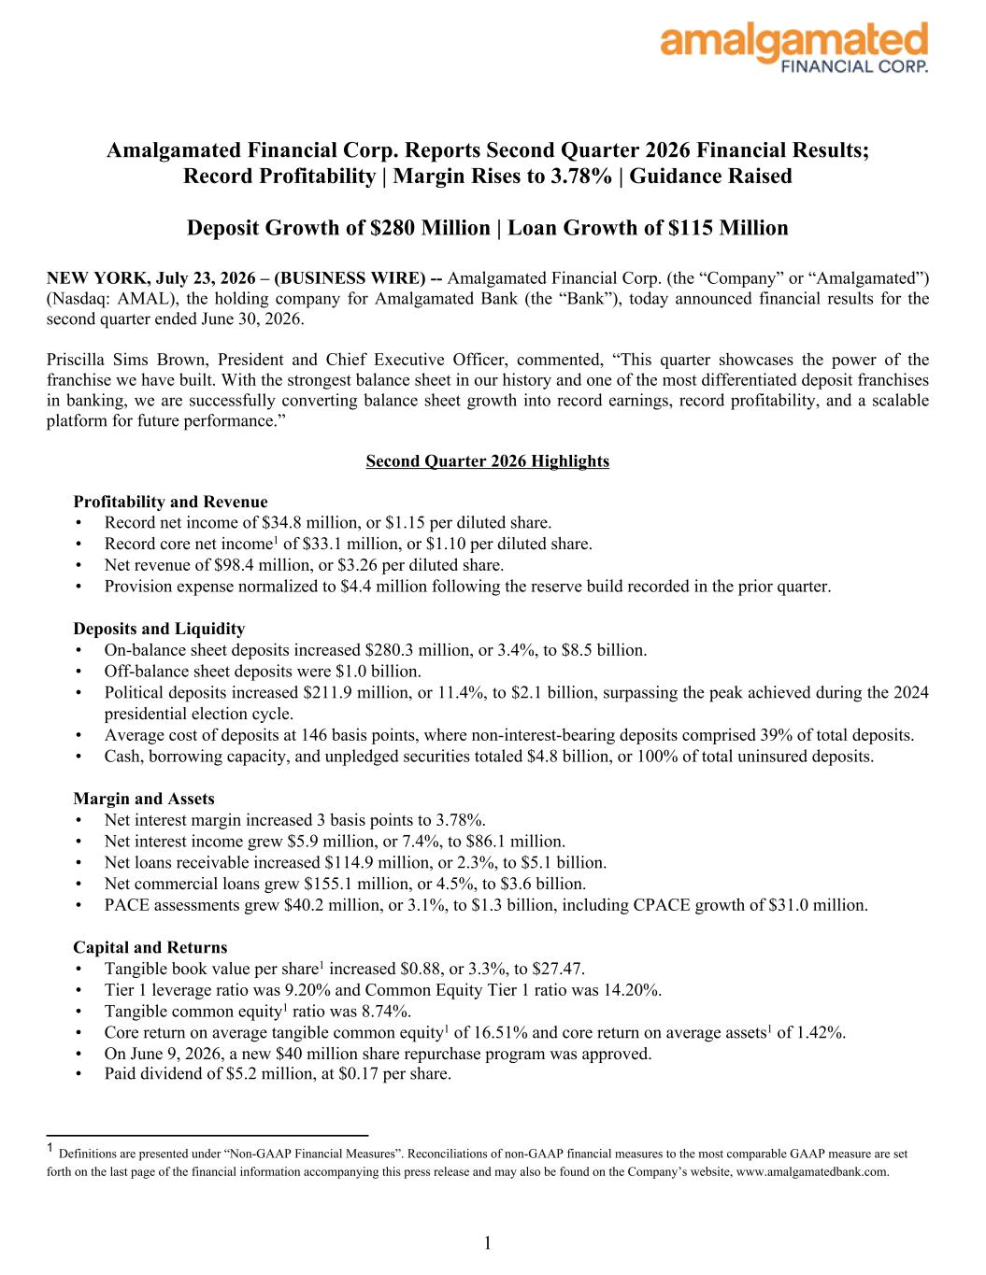

Amalgamated Financial Corp. Reports Second Quarter 2026 Financial Results; Record Profitability | Margin Rises to 3.78% | Guidance Raised Deposit Growth of $280 Million | Loan Growth of $115 Million NEW YORK, July 23, 2026 – (BUSINESS WIRE) -- Amalgamated Financial Corp. (the “Company” or “Amalgamated”) (Nasdaq: AMAL), the holding company for Amalgamated Bank (the “Bank”), today announced financial results for the second quarter ended June 30, 2026. Priscilla Sims Brown, President and Chief Executive Officer, commented, “This quarter showcases the power of the franchise we have built. With the strongest balance sheet in our history and one of the most differentiated deposit franchises in banking, we are successfully converting balance sheet growth into record earnings, record profitability, and a scalable platform for future performance.” Second Quarter 2026 Highlights Profitability and Revenue • Record net income of $34.8 million, or $1.15 per diluted share. • Record core net income1 of $33.1 million, or $1.10 per diluted share. • Net revenue of $98.4 million, or $3.26 per diluted share. • Provision expense normalized to $4.4 million following the reserve build recorded in the prior quarter. Deposits and Liquidity • On-balance sheet deposits increased $280.3 million, or 3.4%, to $8.5 billion. • Off-balance sheet deposits were $1.0 billion. • Political deposits increased $211.9 million, or 11.4%, to $2.1 billion, surpassing the peak achieved during the 2024 presidential election cycle. • Average cost of deposits at 146 basis points, where non-interest-bearing deposits comprised 39% of total deposits. • Cash, borrowing capacity, and unpledged securities totaled $4.8 billion, or 100% of total uninsured deposits. Margin and Assets • Net interest margin increased 3 basis points to 3.78%. • Net interest income grew $5.9 million, or 7.4%, to $86.1 million. • Net loans receivable increased $114.9 million, or 2.3%, to $5.1 billion. • Net commercial loans grew $155.1 million, or 4.5%, to $3.6 billion. • PACE assessments grew $40.2 million, or 3.1%, to $1.3 billion, including CPACE growth of $31.0 million. Capital and Returns • Tangible book value per share1 increased $0.88, or 3.3%, to $27.47. • Tier 1 leverage ratio was 9.20% and Common Equity Tier 1 ratio was 14.20%. • Tangible common equity1 ratio was 8.74%. • Core return on average tangible common equity1 of 16.51% and core return on average assets1 of 1.42%. • On June 9, 2026, a new $40 million share repurchase program was approved. • Paid dividend of $5.2 million, at $0.17 per share. 1 1 Definitions are presented under “Non-GAAP Financial Measures”. Reconciliations of non-GAAP financial measures to the most comparable GAAP measure are set forth on the last page of the financial information accompanying this press release and may also be found on the Company’s website, www.amalgamatedbank.com.

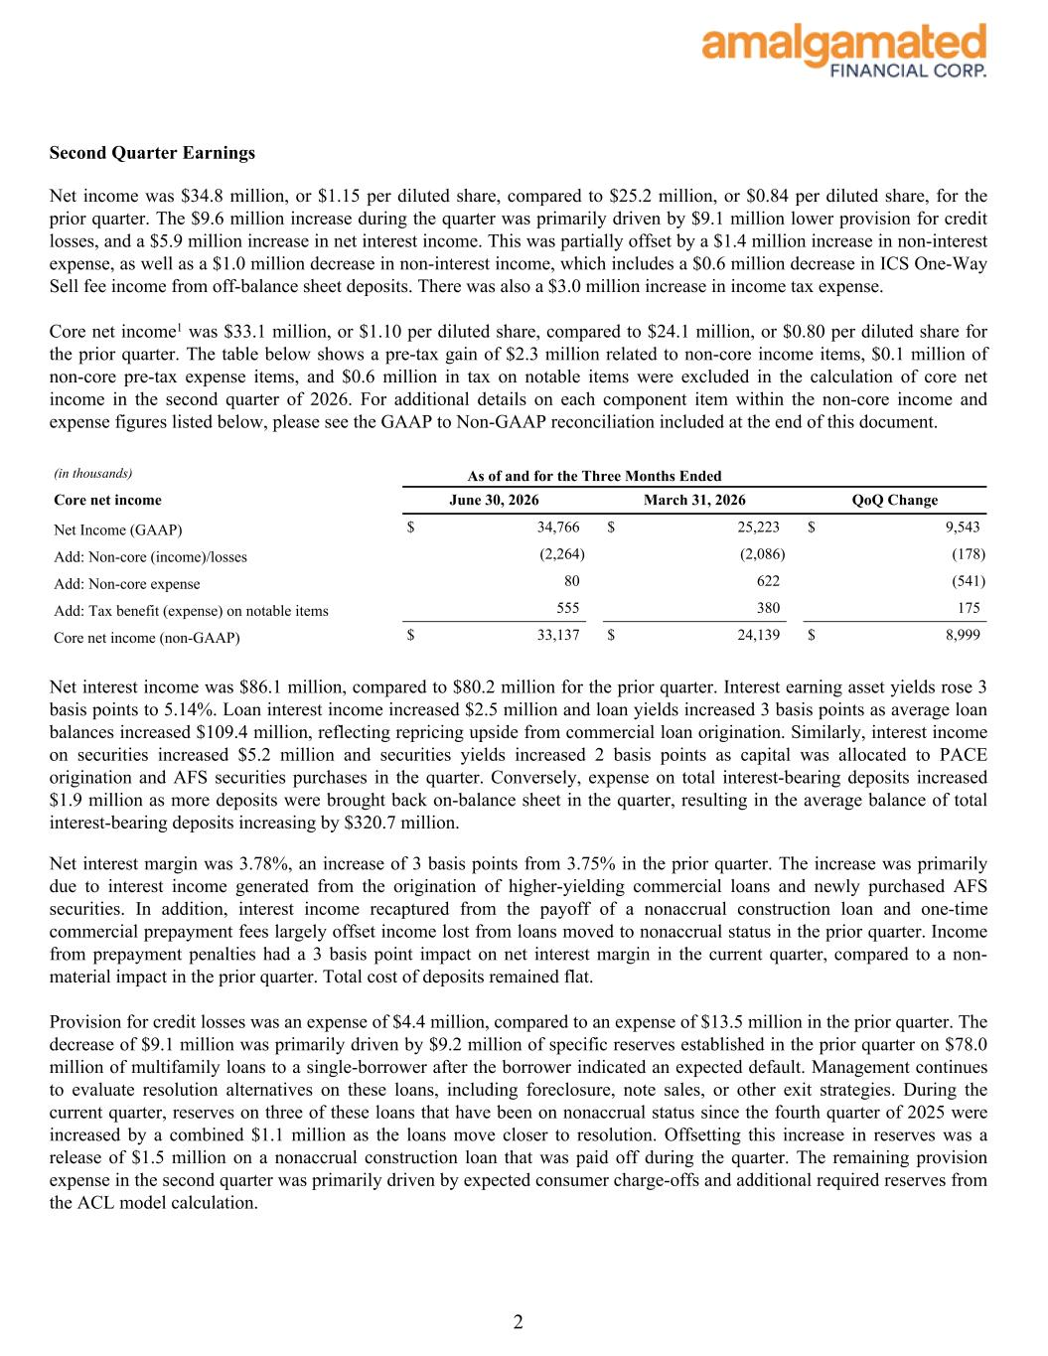
Second Quarter Earnings Net income was $34.8 million, or $1.15 per diluted share, compared to $25.2 million, or $0.84 per diluted share, for the prior quarter. The $9.6 million increase during the quarter was primarily driven by $9.1 million lower provision for credit losses, and a $5.9 million increase in net interest income. This was partially offset by a $1.4 million increase in non-interest expense, as well as a $1.0 million decrease in non-interest income, which includes a $0.6 million decrease in ICS One-Way Sell fee income from off-balance sheet deposits. There was also a $3.0 million increase in income tax expense. Core net income1 was $33.1 million, or $1.10 per diluted share, compared to $24.1 million, or $0.80 per diluted share for the prior quarter. The table below shows a pre-tax gain of $2.3 million related to non-core income items, $0.1 million of non-core pre-tax expense items, and $0.6 million in tax on notable items were excluded in the calculation of core net income in the second quarter of 2026. For additional details on each component item within the non-core income and expense figures listed below, please see the GAAP to Non-GAAP reconciliation included at the end of this document. (in thousands) As of and for the Three Months Ended Core net income June 30, 2026 March 31, 2026 QoQ Change Net Income (GAAP) $ 34,766 $ 25,223 $ 9,543 Add: Non-core (income)/losses (2,264) (2,086) (178) Add: Non-core expense 80 622 (541) Add: Tax benefit (expense) on notable items 555 380 175 Core net income (non-GAAP) $ 33,137 $ 24,139 $ 8,999 Net interest income was $86.1 million, compared to $80.2 million for the prior quarter. Interest earning asset yields rose 3 basis points to 5.14%. Loan interest income increased $2.5 million and loan yields increased 3 basis points as average loan balances increased $109.4 million, reflecting repricing upside from commercial loan origination. Similarly, interest income on securities increased $5.2 million and securities yields increased 2 basis points as capital was allocated to PACE origination and AFS securities purchases in the quarter. Conversely, expense on total interest-bearing deposits increased $1.9 million as more deposits were brought back on-balance sheet in the quarter, resulting in the average balance of total interest-bearing deposits increasing by $320.7 million. Net interest margin was 3.78%, an increase of 3 basis points from 3.75% in the prior quarter. The increase was primarily due to interest income generated from the origination of higher-yielding commercial loans and newly purchased AFS securities. In addition, interest income recaptured from the payoff of a nonaccrual construction loan and one-time commercial prepayment fees largely offset income lost from loans moved to nonaccrual status in the prior quarter. Income from prepayment penalties had a 3 basis point impact on net interest margin in the current quarter, compared to a non- material impact in the prior quarter. Total cost of deposits remained flat. Provision for credit losses was an expense of $4.4 million, compared to an expense of $13.5 million in the prior quarter. The decrease of $9.1 million was primarily driven by $9.2 million of specific reserves established in the prior quarter on $78.0 million of multifamily loans to a single-borrower after the borrower indicated an expected default. Management continues to evaluate resolution alternatives on these loans, including foreclosure, note sales, or other exit strategies. During the current quarter, reserves on three of these loans that have been on nonaccrual status since the fourth quarter of 2025 were increased by a combined $1.1 million as the loans move closer to resolution. Offsetting this increase in reserves was a release of $1.5 million on a nonaccrual construction loan that was paid off during the quarter. The remaining provision expense in the second quarter was primarily driven by expected consumer charge-offs and additional required reserves from the ACL model calculation. 2

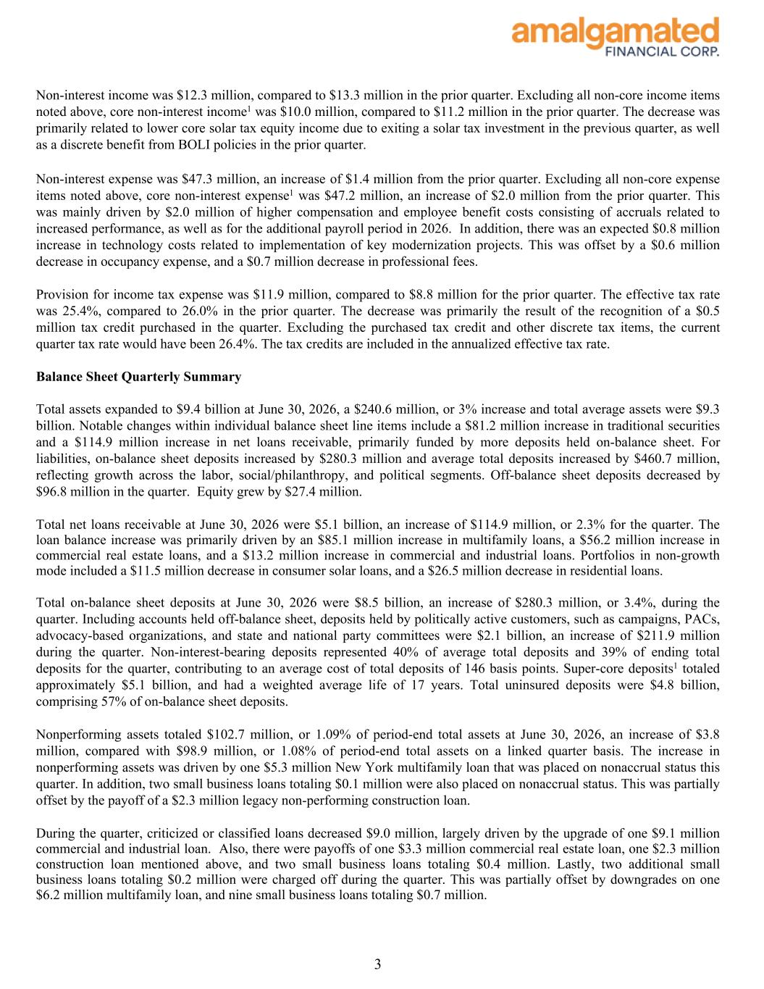
Non-interest income was $12.3 million, compared to $13.3 million in the prior quarter. Excluding all non-core income items noted above, core non-interest income1 was $10.0 million, compared to $11.2 million in the prior quarter. The decrease was primarily related to lower core solar tax equity income due to exiting a solar tax investment in the previous quarter, as well as a discrete benefit from BOLI policies in the prior quarter. Non-interest expense was $47.3 million, an increase of $1.4 million from the prior quarter. Excluding all non-core expense items noted above, core non-interest expense1 was $47.2 million, an increase of $2.0 million from the prior quarter. This was mainly driven by $2.0 million of higher compensation and employee benefit costs consisting of accruals related to increased performance, as well as for the additional payroll period in 2026. In addition, there was an expected $0.8 million increase in technology costs related to implementation of key modernization projects. This was offset by a $0.6 million decrease in occupancy expense, and a $0.7 million decrease in professional fees. Provision for income tax expense was $11.9 million, compared to $8.8 million for the prior quarter. The effective tax rate was 25.4%, compared to 26.0% in the prior quarter. The decrease was primarily the result of the recognition of a $0.5 million tax credit purchased in the quarter. Excluding the purchased tax credit and other discrete tax items, the current quarter tax rate would have been 26.4%. The tax credits are included in the annualized effective tax rate. Balance Sheet Quarterly Summary Total assets expanded to $9.4 billion at June 30, 2026, a $240.6 million, or 3% increase and total average assets were $9.3 billion. Notable changes within individual balance sheet line items include a $81.2 million increase in traditional securities and a $114.9 million increase in net loans receivable, primarily funded by more deposits held on-balance sheet. For liabilities, on-balance sheet deposits increased by $280.3 million and average total deposits increased by $460.7 million, reflecting growth across the labor, social/philanthropy, and political segments. Off-balance sheet deposits decreased by $96.8 million in the quarter. Equity grew by $27.4 million. Total net loans receivable at June 30, 2026 were $5.1 billion, an increase of $114.9 million, or 2.3% for the quarter. The loan balance increase was primarily driven by an $85.1 million increase in multifamily loans, a $56.2 million increase in commercial real estate loans, and a $13.2 million increase in commercial and industrial loans. Portfolios in non-growth mode included a $11.5 million decrease in consumer solar loans, and a $26.5 million decrease in residential loans. Total on-balance sheet deposits at June 30, 2026 were $8.5 billion, an increase of $280.3 million, or 3.4%, during the quarter. Including accounts held off-balance sheet, deposits held by politically active customers, such as campaigns, PACs, advocacy-based organizations, and state and national party committees were $2.1 billion, an increase of $211.9 million during the quarter. Non-interest-bearing deposits represented 40% of average total deposits and 39% of ending total deposits for the quarter, contributing to an average cost of total deposits of 146 basis points. Super-core deposits1 totaled approximately $5.1 billion, and had a weighted average life of 17 years. Total uninsured deposits were $4.8 billion, comprising 57% of on-balance sheet deposits. Nonperforming assets totaled $102.7 million, or 1.09% of period-end total assets at June 30, 2026, an increase of $3.8 million, compared with $98.9 million, or 1.08% of period-end total assets on a linked quarter basis. The increase in nonperforming assets was driven by one $5.3 million New York multifamily loan that was placed on nonaccrual status this quarter. In addition, two small business loans totaling $0.1 million were also placed on nonaccrual status. This was partially offset by the payoff of a $2.3 million legacy non-performing construction loan. During the quarter, criticized or classified loans decreased $9.0 million, largely driven by the upgrade of one $9.1 million commercial and industrial loan. Also, there were payoffs of one $3.3 million commercial real estate loan, one $2.3 million construction loan mentioned above, and two small business loans totaling $0.4 million. Lastly, two additional small business loans totaling $0.2 million were charged off during the quarter. This was partially offset by downgrades on one $6.2 million multifamily loan, and nine small business loans totaling $0.7 million. 3

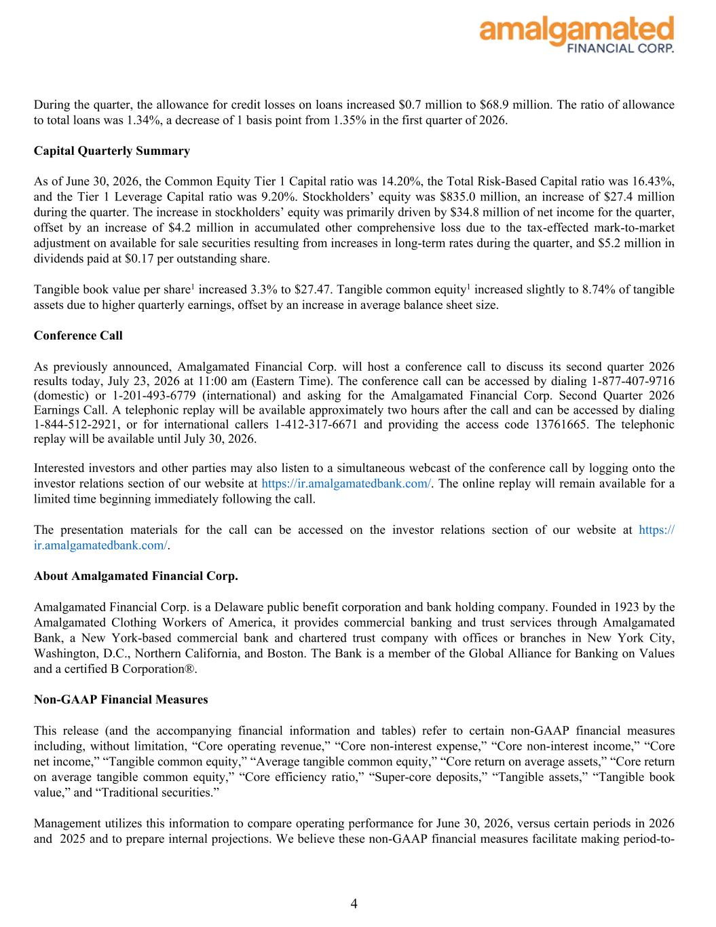
During the quarter, the allowance for credit losses on loans increased $0.7 million to $68.9 million. The ratio of allowance to total loans was 1.34%, a decrease of 1 basis point from 1.35% in the first quarter of 2026. Capital Quarterly Summary As of June 30, 2026, the Common Equity Tier 1 Capital ratio was 14.20%, the Total Risk-Based Capital ratio was 16.43%, and the Tier 1 Leverage Capital ratio was 9.20%. Stockholders’ equity was $835.0 million, an increase of $27.4 million during the quarter. The increase in stockholders’ equity was primarily driven by $34.8 million of net income for the quarter, offset by an increase of $4.2 million in accumulated other comprehensive loss due to the tax-effected mark-to-market adjustment on available for sale securities resulting from increases in long-term rates during the quarter, and $5.2 million in dividends paid at $0.17 per outstanding share. Tangible book value per share1 increased 3.3% to $27.47. Tangible common equity1 increased slightly to 8.74% of tangible assets due to higher quarterly earnings, offset by an increase in average balance sheet size. Conference Call As previously announced, Amalgamated Financial Corp. will host a conference call to discuss its second quarter 2026 results today, July 23, 2026 at 11:00 am (Eastern Time). The conference call can be accessed by dialing 1-877-407-9716 (domestic) or 1-201-493-6779 (international) and asking for the Amalgamated Financial Corp. Second Quarter 2026 Earnings Call. A telephonic replay will be available approximately two hours after the call and can be accessed by dialing 1-844-512-2921, or for international callers 1-412-317-6671 and providing the access code 13761665. The telephonic replay will be available until July 30, 2026. Interested investors and other parties may also listen to a simultaneous webcast of the conference call by logging onto the investor relations section of our website at https://ir.amalgamatedbank.com/. The online replay will remain available for a limited time beginning immediately following the call. The presentation materials for the call can be accessed on the investor relations section of our website at https:// ir.amalgamatedbank.com/. About Amalgamated Financial Corp. Amalgamated Financial Corp. is a Delaware public benefit corporation and bank holding company. Founded in 1923 by the Amalgamated Clothing Workers of America, it provides commercial banking and trust services through Amalgamated Bank, a New York-based commercial bank and chartered trust company with offices or branches in New York City, Washington, D.C., Northern California, and Boston. The Bank is a member of the Global Alliance for Banking on Values and a certified B Corporation®. Non-GAAP Financial Measures This release (and the accompanying financial information and tables) refer to certain non-GAAP financial measures including, without limitation, “Core operating revenue,” “Core non-interest expense,” “Core non-interest income,” “Core net income,” “Tangible common equity,” “Average tangible common equity,” “Core return on average assets,” “Core return on average tangible common equity,” “Core efficiency ratio,” “Super-core deposits,” “Tangible assets,” “Tangible book value,” and “Traditional securities.” Management utilizes this information to compare operating performance for June 30, 2026, versus certain periods in 2026 and 2025 and to prepare internal projections. We believe these non-GAAP financial measures facilitate making period-to- 4

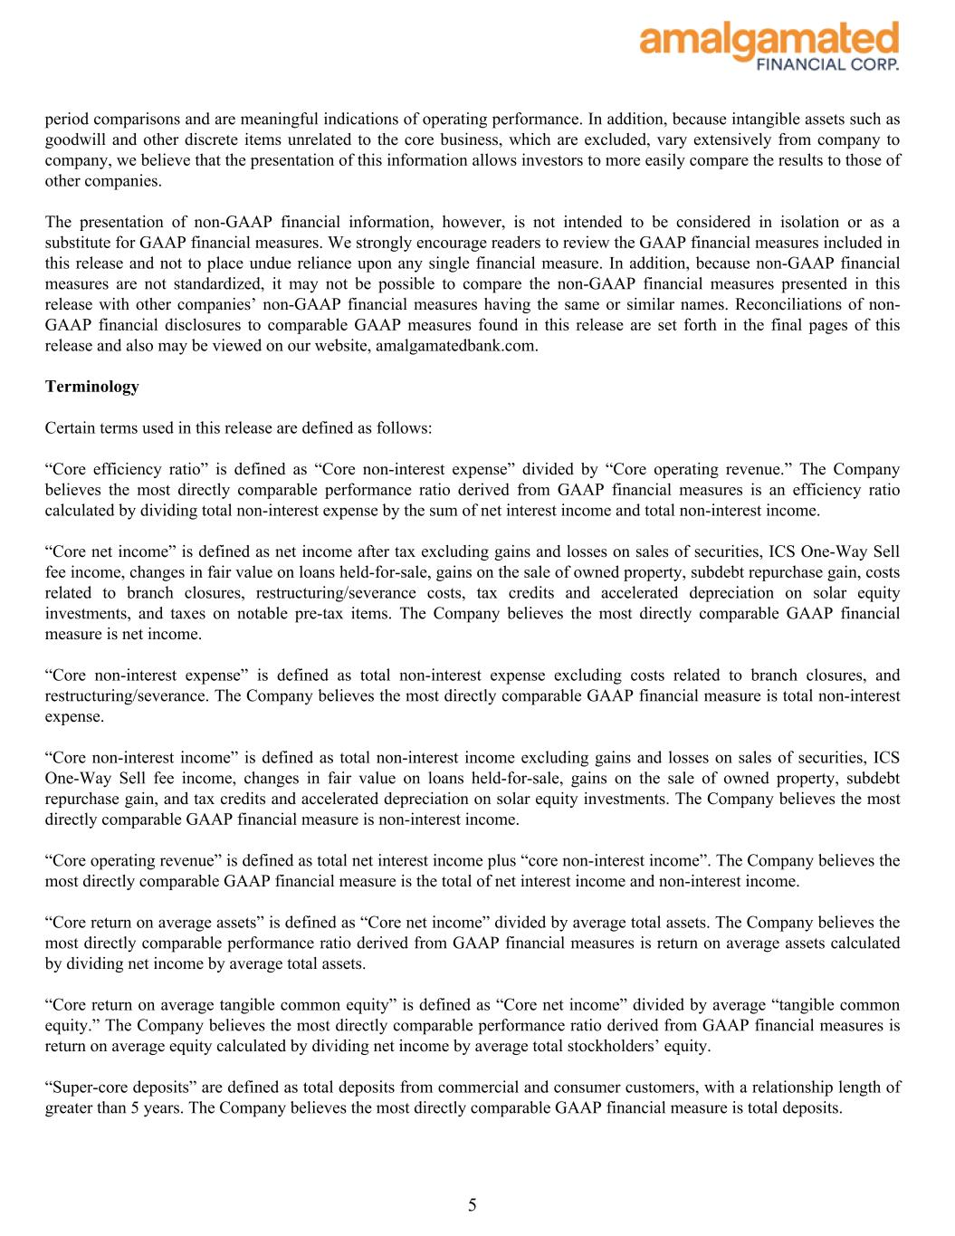
period comparisons and are meaningful indications of operating performance. In addition, because intangible assets such as goodwill and other discrete items unrelated to the core business, which are excluded, vary extensively from company to company, we believe that the presentation of this information allows investors to more easily compare the results to those of other companies. The presentation of non-GAAP financial information, however, is not intended to be considered in isolation or as a substitute for GAAP financial measures. We strongly encourage readers to review the GAAP financial measures included in this release and not to place undue reliance upon any single financial measure. In addition, because non-GAAP financial measures are not standardized, it may not be possible to compare the non-GAAP financial measures presented in this release with other companies’ non-GAAP financial measures having the same or similar names. Reconciliations of non- GAAP financial disclosures to comparable GAAP measures found in this release are set forth in the final pages of this release and also may be viewed on our website, amalgamatedbank.com. Terminology Certain terms used in this release are defined as follows: “Core efficiency ratio” is defined as “Core non-interest expense” divided by “Core operating revenue.” The Company believes the most directly comparable performance ratio derived from GAAP financial measures is an efficiency ratio calculated by dividing total non-interest expense by the sum of net interest income and total non-interest income. “Core net income” is defined as net income after tax excluding gains and losses on sales of securities, ICS One-Way Sell fee income, changes in fair value on loans held-for-sale, gains on the sale of owned property, subdebt repurchase gain, costs related to branch closures, restructuring/severance costs, tax credits and accelerated depreciation on solar equity investments, and taxes on notable pre-tax items. The Company believes the most directly comparable GAAP financial measure is net income. “Core non-interest expense” is defined as total non-interest expense excluding costs related to branch closures, and restructuring/severance. The Company believes the most directly comparable GAAP financial measure is total non-interest expense. “Core non-interest income” is defined as total non-interest income excluding gains and losses on sales of securities, ICS One-Way Sell fee income, changes in fair value on loans held-for-sale, gains on the sale of owned property, subdebt repurchase gain, and tax credits and accelerated depreciation on solar equity investments. The Company believes the most directly comparable GAAP financial measure is non-interest income. “Core operating revenue” is defined as total net interest income plus “core non-interest income”. The Company believes the most directly comparable GAAP financial measure is the total of net interest income and non-interest income. “Core return on average assets” is defined as “Core net income” divided by average total assets. The Company believes the most directly comparable performance ratio derived from GAAP financial measures is return on average assets calculated by dividing net income by average total assets. “Core return on average tangible common equity” is defined as “Core net income” divided by average “tangible common equity.” The Company believes the most directly comparable performance ratio derived from GAAP financial measures is return on average equity calculated by dividing net income by average total stockholders’ equity. “Super-core deposits” are defined as total deposits from commercial and consumer customers, with a relationship length of greater than 5 years. The Company believes the most directly comparable GAAP financial measure is total deposits. 5

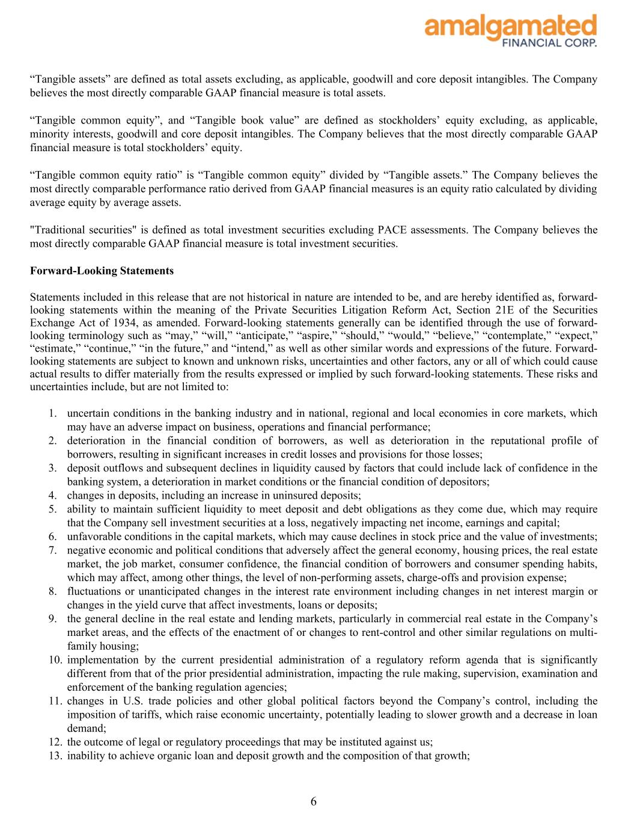
“Tangible assets” are defined as total assets excluding, as applicable, goodwill and core deposit intangibles. The Company believes the most directly comparable GAAP financial measure is total assets. “Tangible common equity”, and “Tangible book value” are defined as stockholders’ equity excluding, as applicable, minority interests, goodwill and core deposit intangibles. The Company believes that the most directly comparable GAAP financial measure is total stockholders’ equity. “Tangible common equity ratio” is “Tangible common equity” divided by “Tangible assets.” The Company believes the most directly comparable performance ratio derived from GAAP financial measures is an equity ratio calculated by dividing average equity by average assets. "Traditional securities" is defined as total investment securities excluding PACE assessments. The Company believes the most directly comparable GAAP financial measure is total investment securities. Forward-Looking Statements Statements included in this release that are not historical in nature are intended to be, and are hereby identified as, forward- looking statements within the meaning of the Private Securities Litigation Reform Act, Section 21E of the Securities Exchange Act of 1934, as amended. Forward-looking statements generally can be identified through the use of forward- looking terminology such as “may,” “will,” “anticipate,” “aspire,” “should,” “would,” “believe,” “contemplate,” “expect,” “estimate,” “continue,” “in the future,” and “intend,” as well as other similar words and expressions of the future. Forward- looking statements are subject to known and unknown risks, uncertainties and other factors, any or all of which could cause actual results to differ materially from the results expressed or implied by such forward-looking statements. These risks and uncertainties include, but are not limited to: 1. uncertain conditions in the banking industry and in national, regional and local economies in core markets, which may have an adverse impact on business, operations and financial performance; 2. deterioration in the financial condition of borrowers, as well as deterioration in the reputational profile of borrowers, resulting in significant increases in credit losses and provisions for those losses; 3. deposit outflows and subsequent declines in liquidity caused by factors that could include lack of confidence in the banking system, a deterioration in market conditions or the financial condition of depositors; 4. changes in deposits, including an increase in uninsured deposits; 5. ability to maintain sufficient liquidity to meet deposit and debt obligations as they come due, which may require that the Company sell investment securities at a loss, negatively impacting net income, earnings and capital; 6. unfavorable conditions in the capital markets, which may cause declines in stock price and the value of investments; 7. negative economic and political conditions that adversely affect the general economy, housing prices, the real estate market, the job market, consumer confidence, the financial condition of borrowers and consumer spending habits, which may affect, among other things, the level of non-performing assets, charge-offs and provision expense; 8. fluctuations or unanticipated changes in the interest rate environment including changes in net interest margin or changes in the yield curve that affect investments, loans or deposits; 9. the general decline in the real estate and lending markets, particularly in commercial real estate in the Company’s market areas, and the effects of the enactment of or changes to rent-control and other similar regulations on multi- family housing; 10. implementation by the current presidential administration of a regulatory reform agenda that is significantly different from that of the prior presidential administration, impacting the rule making, supervision, examination and enforcement of the banking regulation agencies; 11. changes in U.S. trade policies and other global political factors beyond the Company’s control, including the imposition of tariffs, which raise economic uncertainty, potentially leading to slower growth and a decrease in loan demand; 12. the outcome of legal or regulatory proceedings that may be instituted against us; 13. inability to achieve organic loan and deposit growth and the composition of that growth; 6

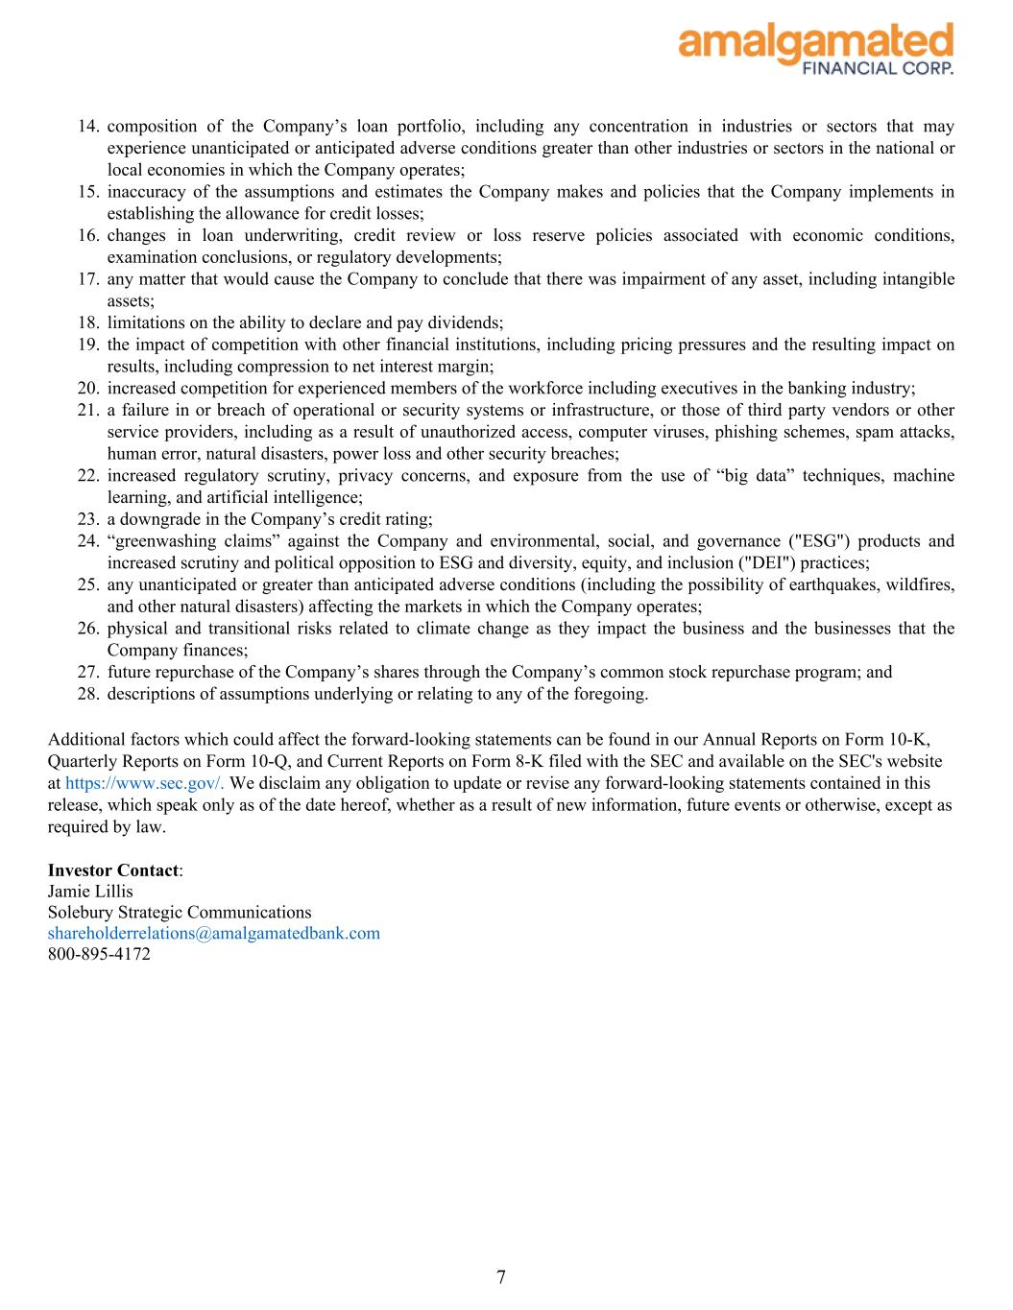
14. composition of the Company’s loan portfolio, including any concentration in industries or sectors that may experience unanticipated or anticipated adverse conditions greater than other industries or sectors in the national or local economies in which the Company operates; 15. inaccuracy of the assumptions and estimates the Company makes and policies that the Company implements in establishing the allowance for credit losses; 16. changes in loan underwriting, credit review or loss reserve policies associated with economic conditions, examination conclusions, or regulatory developments; 17. any matter that would cause the Company to conclude that there was impairment of any asset, including intangible assets; 18. limitations on the ability to declare and pay dividends; 19. the impact of competition with other financial institutions, including pricing pressures and the resulting impact on results, including compression to net interest margin; 20. increased competition for experienced members of the workforce including executives in the banking industry; 21. a failure in or breach of operational or security systems or infrastructure, or those of third party vendors or other service providers, including as a result of unauthorized access, computer viruses, phishing schemes, spam attacks, human error, natural disasters, power loss and other security breaches; 22. increased regulatory scrutiny, privacy concerns, and exposure from the use of “big data” techniques, machine learning, and artificial intelligence; 23. a downgrade in the Company’s credit rating; 24. “greenwashing claims” against the Company and environmental, social, and governance ("ESG") products and increased scrutiny and political opposition to ESG and diversity, equity, and inclusion ("DEI") practices; 25. any unanticipated or greater than anticipated adverse conditions (including the possibility of earthquakes, wildfires, and other natural disasters) affecting the markets in which the Company operates; 26. physical and transitional risks related to climate change as they impact the business and the businesses that the Company finances; 27. future repurchase of the Company’s shares through the Company’s common stock repurchase program; and 28. descriptions of assumptions underlying or relating to any of the foregoing. Additional factors which could affect the forward-looking statements can be found in our Annual Reports on Form 10-K, Quarterly Reports on Form 10-Q, and Current Reports on Form 8-K filed with the SEC and available on the SEC's website at https://www.sec.gov/. We disclaim any obligation to update or revise any forward-looking statements contained in this release, which speak only as of the date hereof, whether as a result of new information, future events or otherwise, except as required by law. Investor Contact: Jamie Lillis Solebury Strategic Communications shareholderrelations@amalgamatedbank.com 800-895-4172 7

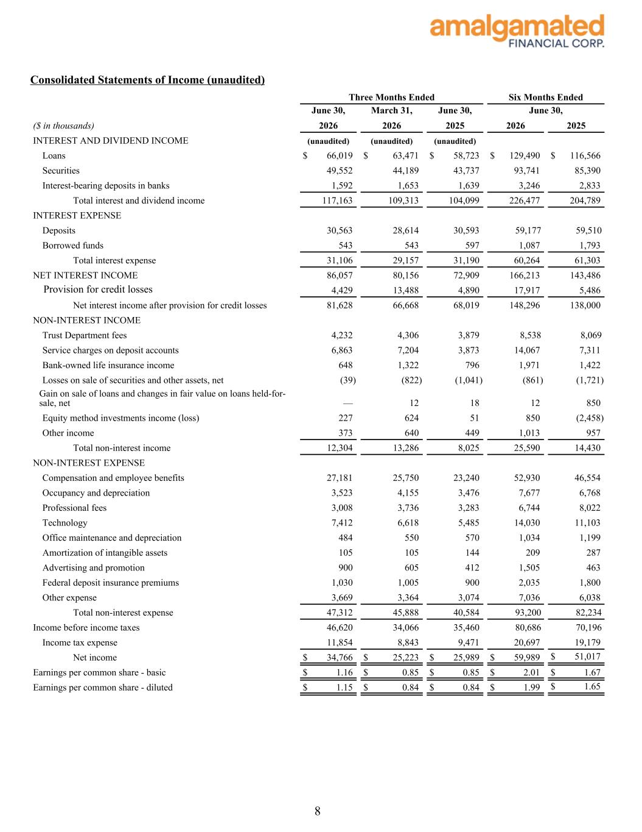
Consolidated Statements of Income (unaudited) June 30, March 31, June 30, June 30, ($ in thousands) 2026 2026 2025 2026 2025 INTEREST AND DIVIDEND INCOME (unaudited) (unaudited) (unaudited) Loans $ 66,019 $ 63,471 $ 58,723 $ 129,490 $ 116,566 Securities 49,552 44,189 43,737 93,741 85,390 Interest-bearing deposits in banks 1,592 1,653 1,639 3,246 2,833 Total interest and dividend income 117,163 109,313 104,099 226,477 204,789 INTEREST EXPENSE Deposits 30,563 28,614 30,593 59,177 59,510 Borrowed funds 543 543 597 1,087 1,793 Total interest expense 31,106 29,157 31,190 60,264 61,303 NET INTEREST INCOME 86,057 80,156 72,909 166,213 143,486 Provision for credit losses 4,429 13,488 4,890 17,917 5,486 Net interest income after provision for credit losses 81,628 66,668 68,019 148,296 138,000 NON-INTEREST INCOME Trust Department fees 4,232 4,306 3,879 8,538 8,069 Service charges on deposit accounts 6,863 7,204 3,873 14,067 7,311 Bank-owned life insurance income 648 1,322 796 1,971 1,422 Losses on sale of securities and other assets, net (39) (822) (1,041) (861) (1,721) Gain on sale of loans and changes in fair value on loans held-for- sale, net — 12 18 12 850 Equity method investments income (loss) 227 624 51 850 (2,458) Other income 373 640 449 1,013 957 Total non-interest income 12,304 13,286 8,025 25,590 14,430 NON-INTEREST EXPENSE Compensation and employee benefits 27,181 25,750 23,240 52,930 46,554 Occupancy and depreciation 3,523 4,155 3,476 7,677 6,768 Professional fees 3,008 3,736 3,283 6,744 8,022 Technology 7,412 6,618 5,485 14,030 11,103 Office maintenance and depreciation 484 550 570 1,034 1,199 Amortization of intangible assets 105 105 144 209 287 Advertising and promotion 900 605 412 1,505 463 Federal deposit insurance premiums 1,030 1,005 900 2,035 1,800 Other expense 3,669 3,364 3,074 7,036 6,038 Total non-interest expense 47,312 45,888 40,584 93,200 82,234 Income before income taxes 46,620 34,066 35,460 80,686 70,196 Income tax expense 11,854 8,843 9,471 20,697 19,179 Net income $ 34,766 $ 25,223 $ 25,989 $ 59,989 $ 51,017 Earnings per common share - basic $ 1.16 $ 0.85 $ 0.85 $ 2.01 $ 1.67 Earnings per common share - diluted $ 1.15 $ 0.84 $ 0.84 $ 1.99 $ 1.65 Three Months Ended Six Months Ended 8

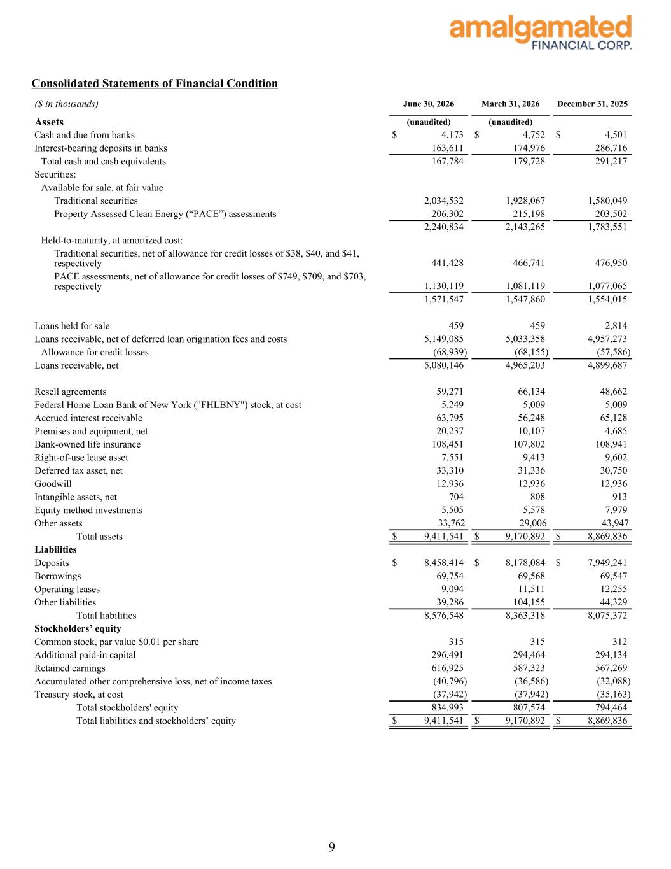
Consolidated Statements of Financial Condition ($ in thousands) June 30, 2026 March 31, 2026 December 31, 2025 Assets (unaudited) (unaudited) Cash and due from banks $ 4,173 $ 4,752 $ 4,501 Interest-bearing deposits in banks 163,611 174,976 286,716 Total cash and cash equivalents 167,784 179,728 291,217 Securities: Available for sale, at fair value Traditional securities 2,034,532 1,928,067 1,580,049 Property Assessed Clean Energy (“PACE”) assessments 206,302 215,198 203,502 2,240,834 2,143,265 1,783,551 Held-to-maturity, at amortized cost: Traditional securities, net of allowance for credit losses of $38, $40, and $41, respectively 441,428 466,741 476,950 PACE assessments, net of allowance for credit losses of $749, $709, and $703, respectively 1,130,119 1,081,119 1,077,065 1,571,547 1,547,860 1,554,015 Loans held for sale 459 459 2,814 Loans receivable, net of deferred loan origination fees and costs 5,149,085 5,033,358 4,957,273 Allowance for credit losses (68,939) (68,155) (57,586) Loans receivable, net 5,080,146 4,965,203 4,899,687 Resell agreements 59,271 66,134 48,662 Federal Home Loan Bank of New York ("FHLBNY") stock, at cost 5,249 5,009 5,009 Accrued interest receivable 63,795 56,248 65,128 Premises and equipment, net 20,237 10,107 4,685 Bank-owned life insurance 108,451 107,802 108,941 Right-of-use lease asset 7,551 9,413 9,602 Deferred tax asset, net 33,310 31,336 30,750 Goodwill 12,936 12,936 12,936 Intangible assets, net 704 808 913 Equity method investments 5,505 5,578 7,979 Other assets 33,762 29,006 43,947 Total assets $ 9,411,541 $ 9,170,892 $ 8,869,836 Liabilities Deposits $ 8,458,414 $ 8,178,084 $ 7,949,241 Borrowings 69,754 69,568 69,547 Operating leases 9,094 11,511 12,255 Other liabilities 39,286 104,155 44,329 Total liabilities 8,576,548 8,363,318 8,075,372 Stockholders’ equity Common stock, par value $0.01 per share 315 315 312 Additional paid-in capital 296,491 294,464 294,134 Retained earnings 616,925 587,323 567,269 Accumulated other comprehensive loss, net of income taxes (40,796) (36,586) (32,088) Treasury stock, at cost (37,942) (37,942) (35,163) Total stockholders' equity 834,993 807,574 794,464 Total liabilities and stockholders’ equity $ 9,411,541 $ 9,170,892 $ 8,869,836 9

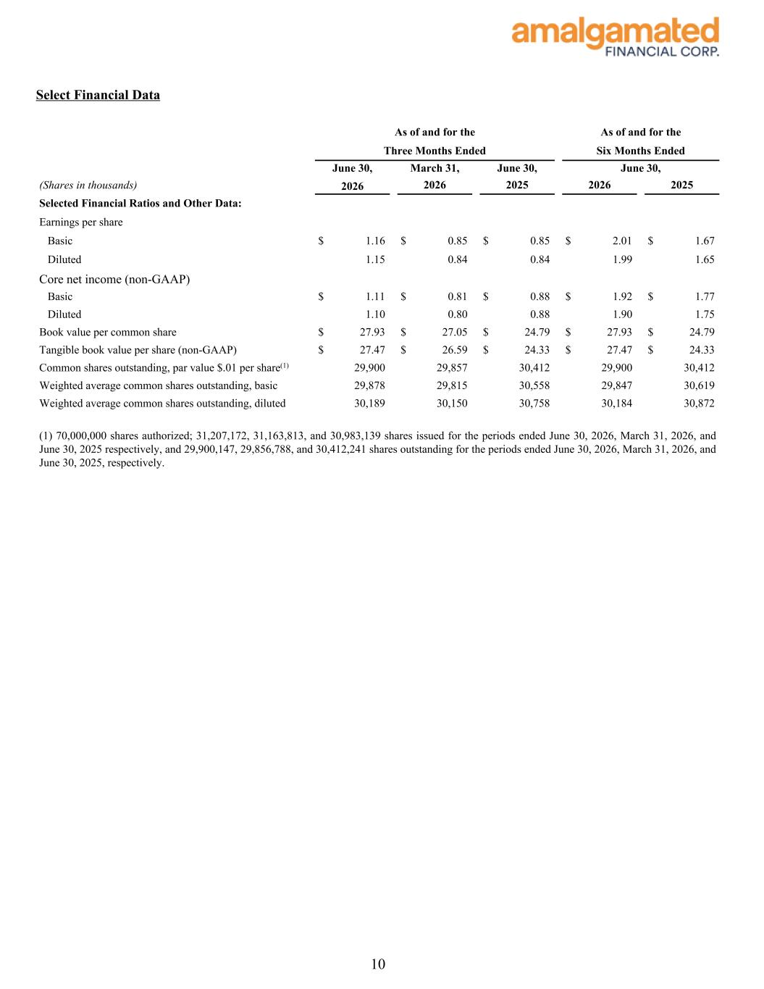
Select Financial Data As of and for the As of and for the Three Months Ended Six Months Ended June 30, March 31, June 30, June 30, (Shares in thousands) 2026 2026 2025 2026 2025 Selected Financial Ratios and Other Data: Earnings per share Basic $ 1.16 $ 0.85 $ 0.85 $ 2.01 $ 1.67 Diluted 1.15 0.84 0.84 1.99 1.65 Core net income (non-GAAP) Basic $ 1.11 $ 0.81 $ 0.88 $ 1.92 $ 1.77 Diluted 1.10 0.80 0.88 1.90 1.75 Book value per common share $ 27.93 $ 27.05 $ 24.79 $ 27.93 $ 24.79 Tangible book value per share (non-GAAP) $ 27.47 $ 26.59 $ 24.33 $ 27.47 $ 24.33 Common shares outstanding, par value $.01 per share(1) 29,900 29,857 30,412 29,900 30,412 Weighted average common shares outstanding, basic 29,878 29,815 30,558 29,847 30,619 Weighted average common shares outstanding, diluted 30,189 30,150 30,758 30,184 30,872 (1) 70,000,000 shares authorized; 31,207,172, 31,163,813, and 30,983,139 shares issued for the periods ended June 30, 2026, March 31, 2026, and June 30, 2025 respectively, and 29,900,147, 29,856,788, and 30,412,241 shares outstanding for the periods ended June 30, 2026, March 31, 2026, and June 30, 2025, respectively. 10

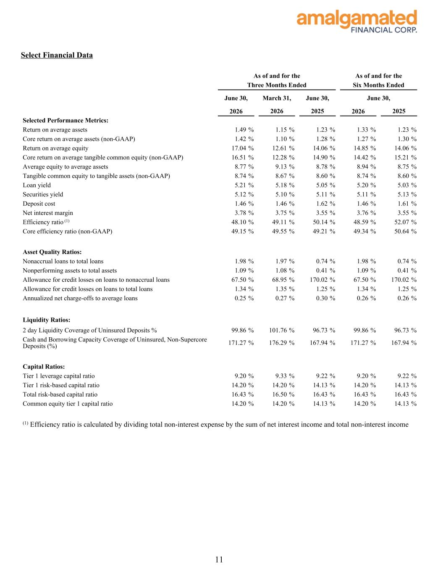
Select Financial Data As of and for the As of and for the Three Months Ended Six Months Ended June 30, March 31, June 30, June 30, 2026 2026 2025 2026 2025 Selected Performance Metrics: Return on average assets 1.49 % 1.15 % 1.23 % 1.33 % 1.23 % Core return on average assets (non-GAAP) 1.42 % 1.10 % 1.28 % 1.27 % 1.30 % Return on average equity 17.04 % 12.61 % 14.06 % 14.85 % 14.06 % Core return on average tangible common equity (non-GAAP) 16.51 % 12.28 % 14.90 % 14.42 % 15.21 % Average equity to average assets 8.77 % 9.13 % 8.78 % 8.94 % 8.75 % Tangible common equity to tangible assets (non-GAAP) 8.74 % 8.67 % 8.60 % 8.74 % 8.60 % Loan yield 5.21 % 5.18 % 5.05 % 5.20 % 5.03 % Securities yield 5.12 % 5.10 % 5.11 % 5.11 % 5.13 % Deposit cost 1.46 % 1.46 % 1.62 % 1.46 % 1.61 % Net interest margin 3.78 % 3.75 % 3.55 % 3.76 % 3.55 % Efficiency ratio (1) 48.10 % 49.11 % 50.14 % 48.59 % 52.07 % Core efficiency ratio (non-GAAP) 49.15 % 49.55 % 49.21 % 49.34 % 50.64 % Asset Quality Ratios: Nonaccrual loans to total loans 1.98 % 1.97 % 0.74 % 1.98 % 0.74 % Nonperforming assets to total assets 1.09 % 1.08 % 0.41 % 1.09 % 0.41 % Allowance for credit losses on loans to nonaccrual loans 67.50 % 68.95 % 170.02 % 67.50 % 170.02 % Allowance for credit losses on loans to total loans 1.34 % 1.35 % 1.25 % 1.34 % 1.25 % Annualized net charge-offs to average loans 0.25 % 0.27 % 0.30 % 0.26 % 0.26 % Liquidity Ratios: 2 day Liquidity Coverage of Uninsured Deposits % 99.86 % 101.76 % 96.73 % 99.86 % 96.73 % Cash and Borrowing Capacity Coverage of Uninsured, Non-Supercore Deposits (%) 171.27 % 176.29 % 167.94 % 171.27 % 167.94 % Capital Ratios: Tier 1 leverage capital ratio 9.20 % 9.33 % 9.22 % 9.20 % 9.22 % Tier 1 risk-based capital ratio 14.20 % 14.20 % 14.13 % 14.20 % 14.13 % Total risk-based capital ratio 16.43 % 16.50 % 16.43 % 16.43 % 16.43 % Common equity tier 1 capital ratio 14.20 % 14.20 % 14.13 % 14.20 % 14.13 % (1) Efficiency ratio is calculated by dividing total non-interest expense by the sum of net interest income and total non-interest income 11

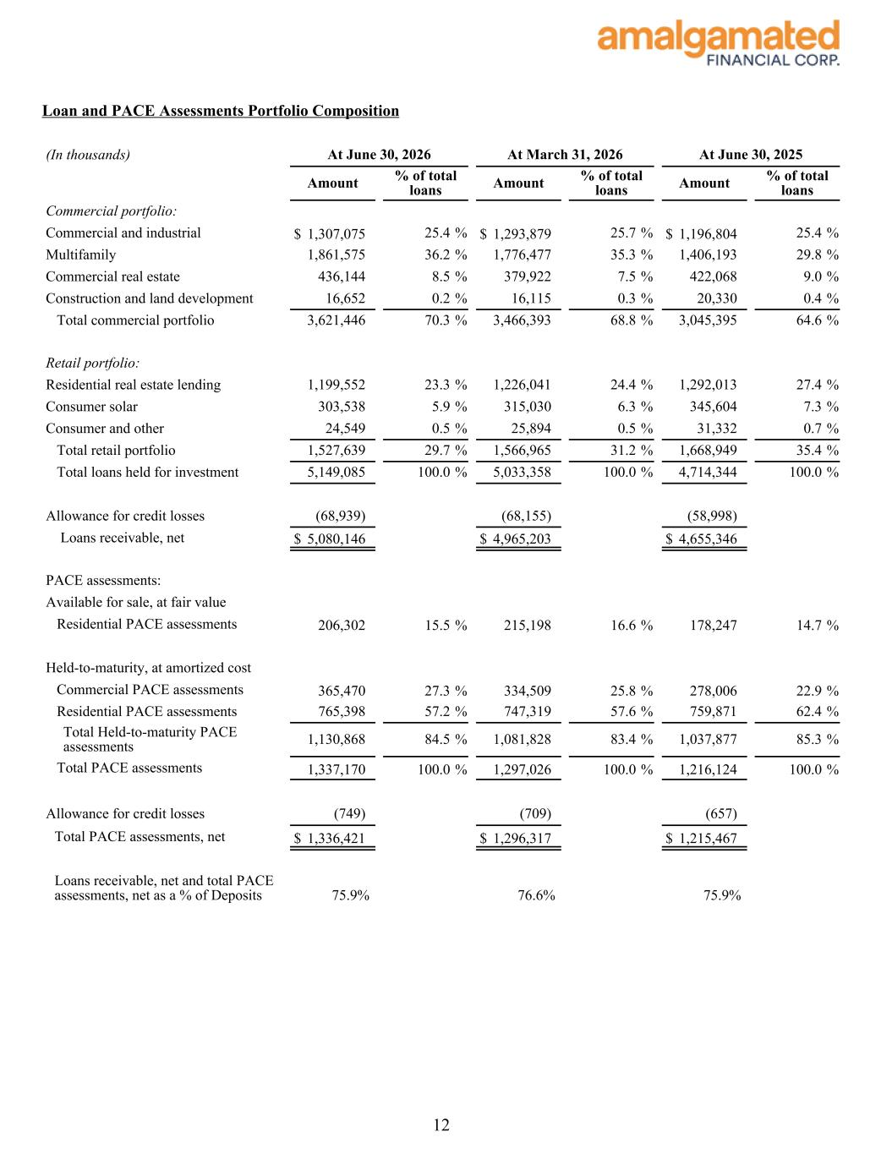
Loan and PACE Assessments Portfolio Composition (In thousands) At June 30, 2026 At March 31, 2026 At June 30, 2025 Amount % of total loans Amount % of total loans Amount % of total loans Commercial portfolio: Commercial and industrial $ 1,307,075 25.4 % $ 1,293,879 25.7 % $ 1,196,804 25.4 % Multifamily 1,861,575 36.2 % 1,776,477 35.3 % 1,406,193 29.8 % Commercial real estate 436,144 8.5 % 379,922 7.5 % 422,068 9.0 % Construction and land development 16,652 0.2 % 16,115 0.3 % 20,330 0.4 % Total commercial portfolio 3,621,446 70.3 % 3,466,393 68.8 % 3,045,395 64.6 % Retail portfolio: Residential real estate lending 1,199,552 23.3 % 1,226,041 24.4 % 1,292,013 27.4 % Consumer solar 303,538 5.9 % 315,030 6.3 % 345,604 7.3 % Consumer and other 24,549 0.5 % 25,894 0.5 % 31,332 0.7 % Total retail portfolio 1,527,639 29.7 % 1,566,965 31.2 % 1,668,949 35.4 % Total loans held for investment 5,149,085 100.0 % 5,033,358 100.0 % 4,714,344 100.0 % Allowance for credit losses (68,939) (68,155) (58,998) Loans receivable, net $ 5,080,146 $ 4,965,203 $ 4,655,346 PACE assessments: Available for sale, at fair value Residential PACE assessments 206,302 15.5 % 215,198 16.6 % 178,247 14.7 % Held-to-maturity, at amortized cost Commercial PACE assessments 365,470 27.3 % 334,509 25.8 % 278,006 22.9 % Residential PACE assessments 765,398 57.2 % 747,319 57.6 % 759,871 62.4 % Total Held-to-maturity PACE assessments 1,130,868 84.5 % 1,081,828 83.4 % 1,037,877 85.3 % Total PACE assessments 1,337,170 100.0 % 1,297,026 100.0 % 1,216,124 100.0 % Allowance for credit losses (749) (709) (657) Total PACE assessments, net $ 1,336,421 $ 1,296,317 $ 1,215,467 Loans receivable, net and total PACE assessments, net as a % of Deposits 75.9% 76.6% 75.9% 12

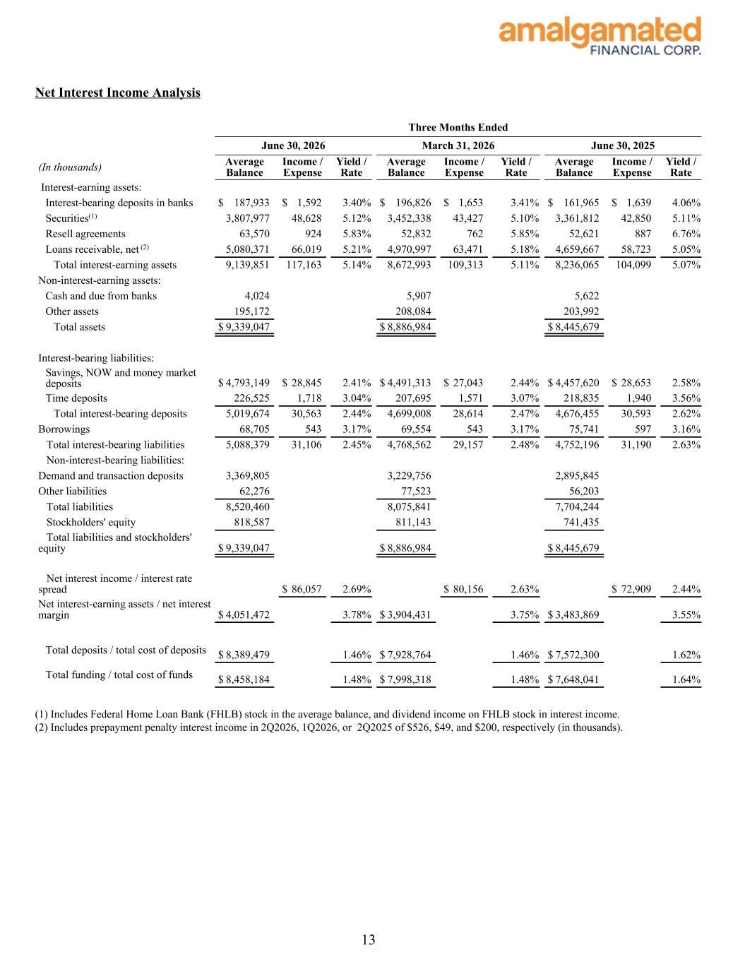
Net Interest Income Analysis Three Months Ended June 30, 2026 March 31, 2026 June 30, 2025 (In thousands) Average Balance Income / Expense Yield / Rate Average Balance Income / Expense Yield / Rate Average Balance Income / Expense Yield / Rate Interest-earning assets: Interest-bearing deposits in banks $ 187,933 $ 1,592 3.40 % $ 196,826 $ 1,653 3.41 % $ 161,965 $ 1,639 4.06 % Securities(1) 3,807,977 48,628 5.12 % 3,452,338 43,427 5.10 % 3,361,812 42,850 5.11 % Resell agreements 63,570 924 5.83 % 52,832 762 5.85 % 52,621 887 6.76 % Loans receivable, net (2) 5,080,371 66,019 5.21 % 4,970,997 63,471 5.18 % 4,659,667 58,723 5.05 % Total interest-earning assets 9,139,851 117,163 5.14 % 8,672,993 109,313 5.11 % 8,236,065 104,099 5.07 % Non-interest-earning assets: Cash and due from banks 4,024 5,907 5,622 Other assets 195,172 208,084 203,992 Total assets $ 9,339,047 $ 8,886,984 $ 8,445,679 Interest-bearing liabilities: Savings, NOW and money market deposits $ 4,793,149 $ 28,845 2.41 % $ 4,491,313 $ 27,043 2.44 % $ 4,457,620 $ 28,653 2.58 % Time deposits 226,525 1,718 3.04 % 207,695 1,571 3.07 % 218,835 1,940 3.56 % Total interest-bearing deposits 5,019,674 30,563 2.44 % 4,699,008 28,614 2.47 % 4,676,455 30,593 2.62 % Borrowings 68,705 543 3.17 % 69,554 543 3.17 % 75,741 597 3.16 % Total interest-bearing liabilities 5,088,379 31,106 2.45 % 4,768,562 29,157 2.48 % 4,752,196 31,190 2.63 % Non-interest-bearing liabilities: Demand and transaction deposits 3,369,805 3,229,756 2,895,845 Other liabilities 62,276 77,523 56,203 Total liabilities 8,520,460 8,075,841 7,704,244 Stockholders' equity 818,587 811,143 741,435 Total liabilities and stockholders' equity $ 9,339,047 $ 8,886,984 $ 8,445,679 Net interest income / interest rate spread $ 86,057 2.69 % $ 80,156 2.63 % $ 72,909 2.44 % Net interest-earning assets / net interest margin $ 4,051,472 3.78 % $ 3,904,431 3.75 % $ 3,483,869 3.55 % Total deposits / total cost of deposits $ 8,389,479 1.46 % $ 7,928,764 1.46 % $ 7,572,300 1.62 % Total funding / total cost of funds $ 8,458,184 1.48 % $ 7,998,318 1.48 % $ 7,648,041 1.64 % (1) Includes Federal Home Loan Bank (FHLB) stock in the average balance, and dividend income on FHLB stock in interest income. (2) Includes prepayment penalty interest income in 2Q2026, 1Q2026, or 2Q2025 of $526, $49, and $200, respectively (in thousands). 13

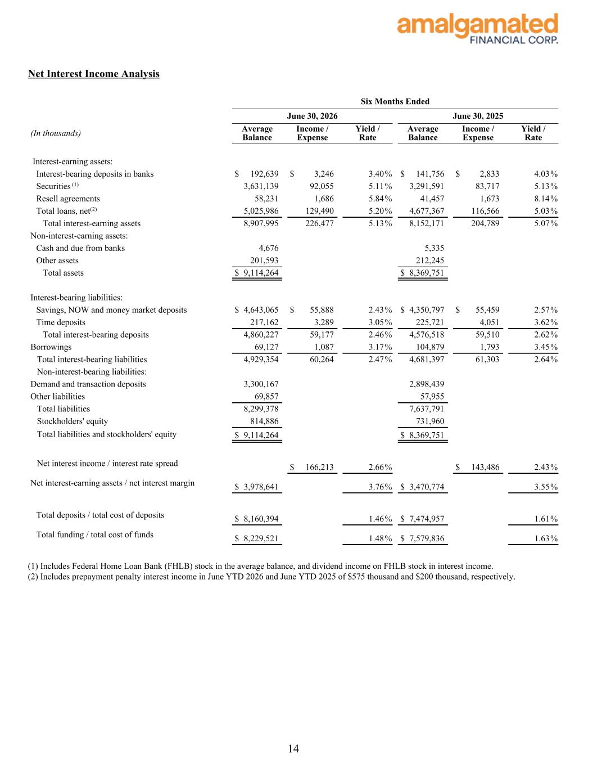
Net Interest Income Analysis Six Months Ended June 30, 2026 June 30, 2025 (In thousands) Average Balance Income / Expense Yield / Rate Average Balance Income / Expense Yield / Rate Interest-earning assets: Interest-bearing deposits in banks $ 192,639 $ 3,246 3.40 % $ 141,756 $ 2,833 4.03 % Securities (1) 3,631,139 92,055 5.11 % 3,291,591 83,717 5.13 % Resell agreements 58,231 1,686 5.84 % 41,457 1,673 8.14 % Total loans, net(2) 5,025,986 129,490 5.20 % 4,677,367 116,566 5.03 % Total interest-earning assets 8,907,995 226,477 5.13 % 8,152,171 204,789 5.07 % Non-interest-earning assets: Cash and due from banks 4,676 5,335 Other assets 201,593 212,245 Total assets $ 9,114,264 $ 8,369,751 Interest-bearing liabilities: Savings, NOW and money market deposits $ 4,643,065 $ 55,888 2.43 % $ 4,350,797 $ 55,459 2.57 % Time deposits 217,162 3,289 3.05 % 225,721 4,051 3.62 % Total interest-bearing deposits 4,860,227 59,177 2.46 % 4,576,518 59,510 2.62 % Borrowings 69,127 1,087 3.17 % 104,879 1,793 3.45 % Total interest-bearing liabilities 4,929,354 60,264 2.47 % 4,681,397 61,303 2.64 % Non-interest-bearing liabilities: Demand and transaction deposits 3,300,167 2,898,439 Other liabilities 69,857 57,955 Total liabilities 8,299,378 7,637,791 Stockholders' equity 814,886 731,960 Total liabilities and stockholders' equity $ 9,114,264 $ 8,369,751 Net interest income / interest rate spread $ 166,213 2.66 % $ 143,486 2.43 % Net interest-earning assets / net interest margin $ 3,978,641 3.76 % $ 3,470,774 3.55 % Total deposits / total cost of deposits $ 8,160,394 1.46 % $ 7,474,957 1.61 % Total funding / total cost of funds $ 8,229,521 1.48 % $ 7,579,836 1.63 % (1) Includes Federal Home Loan Bank (FHLB) stock in the average balance, and dividend income on FHLB stock in interest income. (2) Includes prepayment penalty interest income in June YTD 2026 and June YTD 2025 of $575 thousand and $200 thousand, respectively. 14

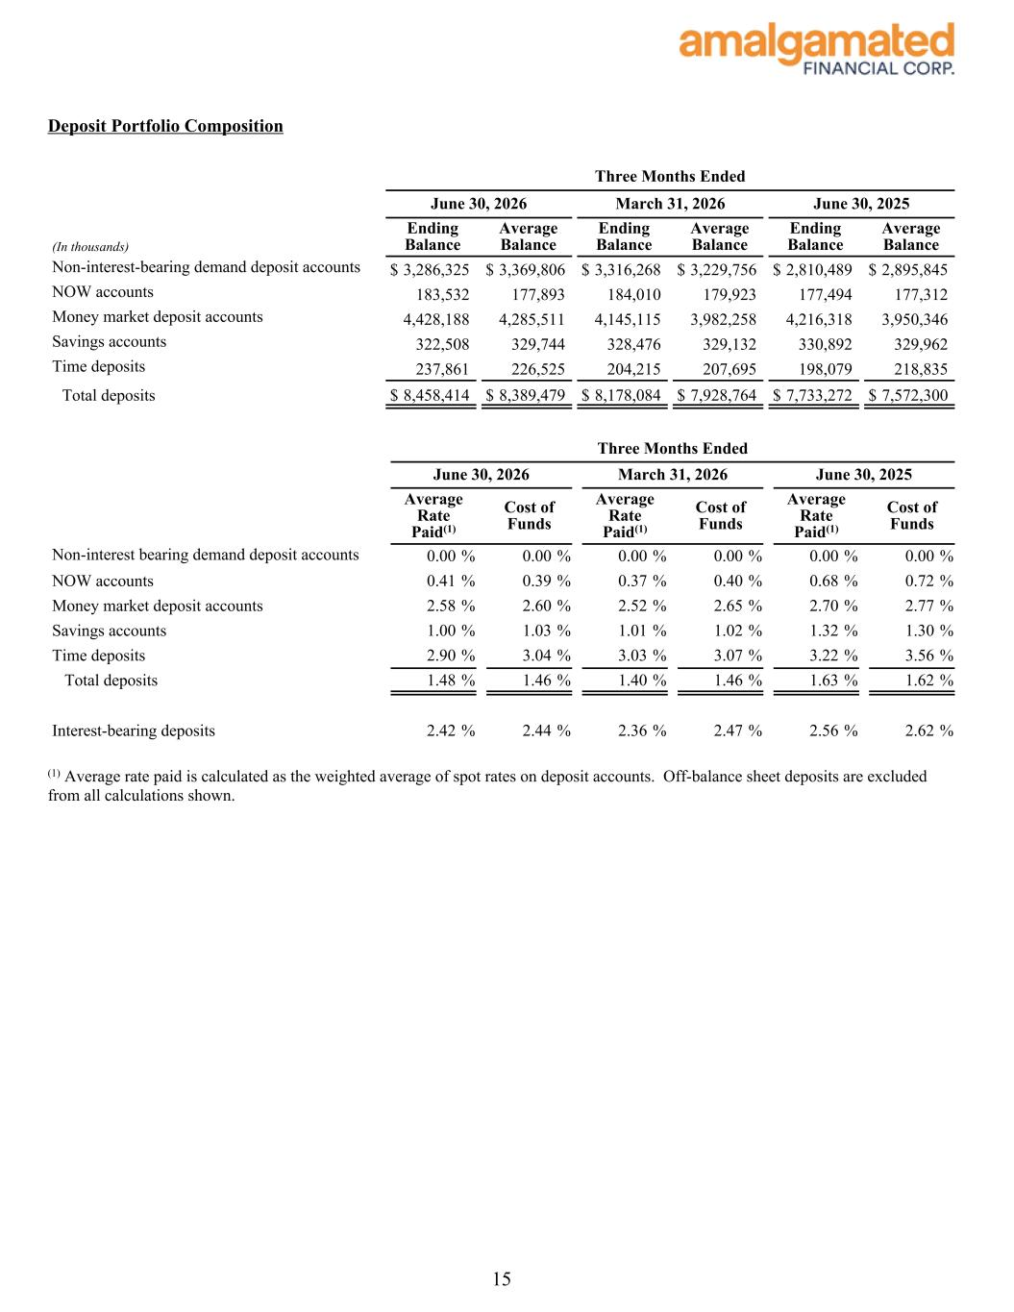
Deposit Portfolio Composition Three Months Ended June 30, 2026 March 31, 2026 June 30, 2025 (In thousands) Ending Balance Average Balance Ending Balance Average Balance Ending Balance Average Balance Non-interest-bearing demand deposit accounts $ 3,286,325 $ 3,369,806 $ 3,316,268 $ 3,229,756 $ 2,810,489 $ 2,895,845 NOW accounts 183,532 177,893 184,010 179,923 177,494 177,312 Money market deposit accounts 4,428,188 4,285,511 4,145,115 3,982,258 4,216,318 3,950,346 Savings accounts 322,508 329,744 328,476 329,132 330,892 329,962 Time deposits 237,861 226,525 204,215 207,695 198,079 218,835 Total deposits $ 8,458,414 $ 8,389,479 $ 8,178,084 $ 7,928,764 $ 7,733,272 $ 7,572,300 Three Months Ended June 30, 2026 March 31, 2026 June 30, 2025 Average Rate Paid(1) Cost of Funds Average Rate Paid(1) Cost of Funds Average Rate Paid(1) Cost of Funds Non-interest bearing demand deposit accounts 0.00 % 0.00 % 0.00 % 0.00 % 0.00 % 0.00 % NOW accounts 0.41 % 0.39 % 0.37 % 0.40 % 0.68 % 0.72 % Money market deposit accounts 2.58 % 2.60 % 2.52 % 2.65 % 2.70 % 2.77 % Savings accounts 1.00 % 1.03 % 1.01 % 1.02 % 1.32 % 1.30 % Time deposits 2.90 % 3.04 % 3.03 % 3.07 % 3.22 % 3.56 % Total deposits 1.48 % 1.46 % 1.40 % 1.46 % 1.63 % 1.62 % Interest-bearing deposits 2.42 % 2.44 % 2.36 % 2.47 % 2.56 % 2.62 % (1) Average rate paid is calculated as the weighted average of spot rates on deposit accounts. Off-balance sheet deposits are excluded from all calculations shown. 15

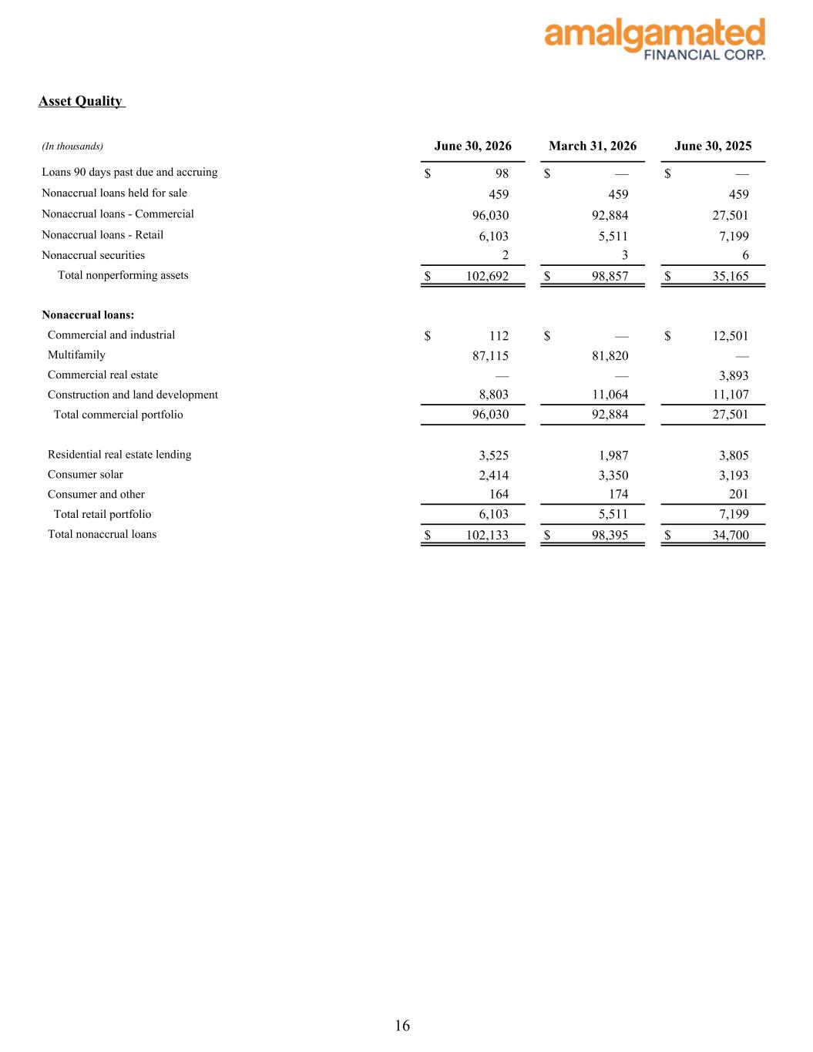
Asset Quality (In thousands) June 30, 2026 March 31, 2026 June 30, 2025 Loans 90 days past due and accruing $ 98 $ — $ — Nonaccrual loans held for sale 459 459 459 Nonaccrual loans - Commercial 96,030 92,884 27,501 Nonaccrual loans - Retail 6,103 5,511 7,199 Nonaccrual securities 2 3 6 Total nonperforming assets $ 102,692 $ 98,857 $ 35,165 Nonaccrual loans: Commercial and industrial $ 112 $ — $ 12,501 Multifamily 87,115 81,820 — Commercial real estate — — 3,893 Construction and land development 8,803 11,064 11,107 Total commercial portfolio 96,030 92,884 27,501 Residential real estate lending 3,525 1,987 3,805 Consumer solar 2,414 3,350 3,193 Consumer and other 164 174 201 Total retail portfolio 6,103 5,511 7,199 Total nonaccrual loans $ 102,133 $ 98,395 $ 34,700 16

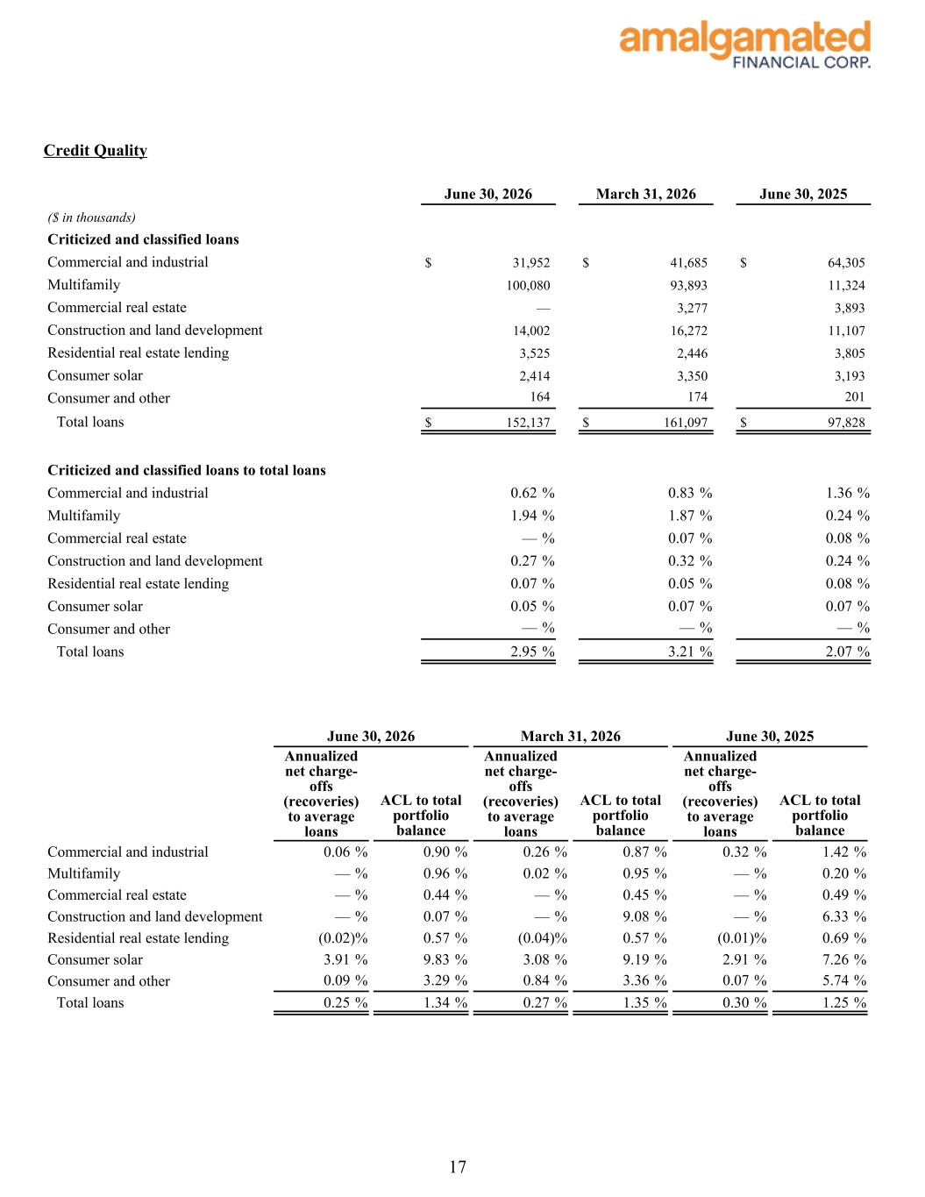
Credit Quality June 30, 2026 March 31, 2026 June 30, 2025 ($ in thousands) Criticized and classified loans Commercial and industrial $ 31,952 $ 41,685 $ 64,305 Multifamily 100,080 93,893 11,324 Commercial real estate — 3,277 3,893 Construction and land development 14,002 16,272 11,107 Residential real estate lending 3,525 2,446 3,805 Consumer solar 2,414 3,350 3,193 Consumer and other 164 174 201 Total loans $ 152,137 $ 161,097 $ 97,828 Criticized and classified loans to total loans Commercial and industrial 0.62 % 0.83 % 1.36 % Multifamily 1.94 % 1.87 % 0.24 % Commercial real estate — % 0.07 % 0.08 % Construction and land development 0.27 % 0.32 % 0.24 % Residential real estate lending 0.07 % 0.05 % 0.08 % Consumer solar 0.05 % 0.07 % 0.07 % Consumer and other — % — % — % Total loans 2.95 % 3.21 % 2.07 % June 30, 2026 March 31, 2026 June 30, 2025 Annualized net charge- offs (recoveries) to average loans ACL to total portfolio balance Annualized net charge- offs (recoveries) to average loans ACL to total portfolio balance Annualized net charge- offs (recoveries) to average loans ACL to total portfolio balance Commercial and industrial 0.06 % 0.90 % 0.26 % 0.87 % 0.32 % 1.42 % Multifamily — % 0.96 % 0.02 % 0.95 % — % 0.20 % Commercial real estate — % 0.44 % — % 0.45 % — % 0.49 % Construction and land development — % 0.07 % — % 9.08 % — % 6.33 % Residential real estate lending (0.02) % 0.57 % (0.04) % 0.57 % (0.01) % 0.69 % Consumer solar 3.91 % 9.83 % 3.08 % 9.19 % 2.91 % 7.26 % Consumer and other 0.09 % 3.29 % 0.84 % 3.36 % 0.07 % 5.74 % Total loans 0.25 % 1.34 % 0.27 % 1.35 % 0.30 % 1.25 % 17

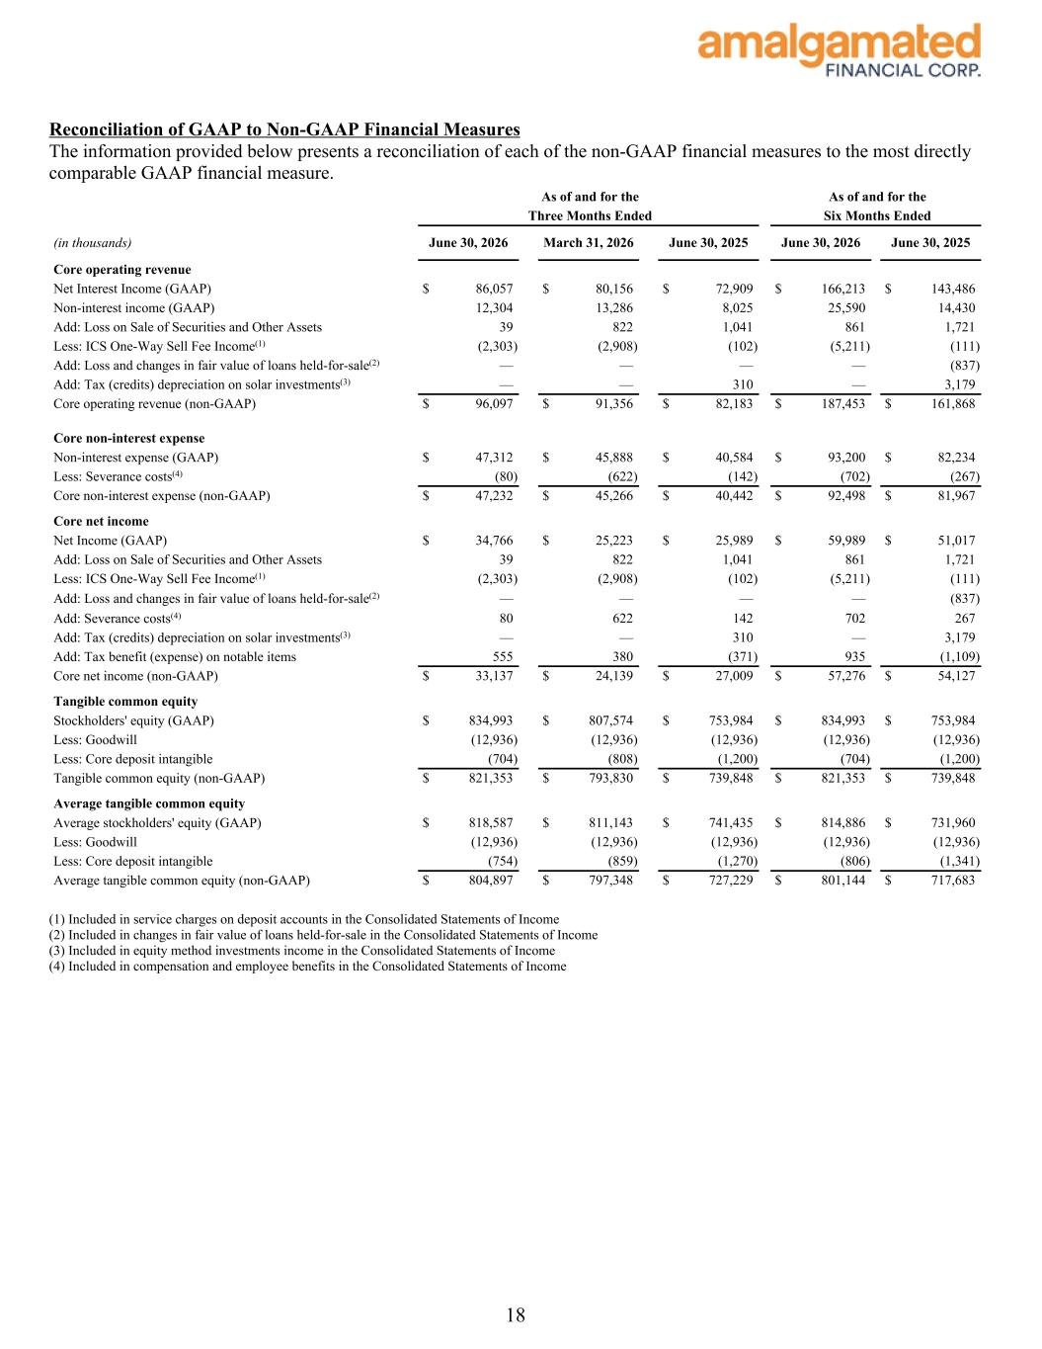
Reconciliation of GAAP to Non-GAAP Financial Measures The information provided below presents a reconciliation of each of the non-GAAP financial measures to the most directly comparable GAAP financial measure. As of and for the As of and for the Three Months Ended Six Months Ended (in thousands) June 30, 2026 March 31, 2026 June 30, 2025 June 30, 2026 June 30, 2025 Core operating revenue Net Interest Income (GAAP) $ 86,057 $ 80,156 $ 72,909 $ 166,213 $ 143,486 Non-interest income (GAAP) 12,304 13,286 8,025 25,590 14,430 Add: Loss on Sale of Securities and Other Assets 39 822 1,041 861 1,721 Less: ICS One-Way Sell Fee Income(1) (2,303) (2,908) (102) (5,211) (111) Add: Loss and changes in fair value of loans held-for-sale(2) — — — — (837) Add: Tax (credits) depreciation on solar investments(3) — — 310 — 3,179 Core operating revenue (non-GAAP) $ 96,097 $ 91,356 $ 82,183 $ 187,453 $ 161,868 Core non-interest expense Non-interest expense (GAAP) $ 47,312 $ 45,888 $ 40,584 $ 93,200 $ 82,234 Less: Severance costs(4) (80) (622) (142) (702) (267) Core non-interest expense (non-GAAP) $ 47,232 $ 45,266 $ 40,442 $ 92,498 $ 81,967 Core net income Net Income (GAAP) $ 34,766 $ 25,223 $ 25,989 $ 59,989 $ 51,017 Add: Loss on Sale of Securities and Other Assets 39 822 1,041 861 1,721 Less: ICS One-Way Sell Fee Income(1) (2,303) (2,908) (102) (5,211) (111) Add: Loss and changes in fair value of loans held-for-sale(2) — — — — (837) Add: Severance costs(4) 80 622 142 702 267 Add: Tax (credits) depreciation on solar investments(3) — — 310 — 3,179 Add: Tax benefit (expense) on notable items 555 380 (371) 935 (1,109) Core net income (non-GAAP) $ 33,137 $ 24,139 $ 27,009 $ 57,276 $ 54,127 Tangible common equity Stockholders' equity (GAAP) $ 834,993 $ 807,574 $ 753,984 $ 834,993 $ 753,984 Less: Goodwill (12,936) (12,936) (12,936) (12,936) (12,936) Less: Core deposit intangible (704) (808) (1,200) (704) (1,200) Tangible common equity (non-GAAP) $ 821,353 $ 793,830 $ 739,848 $ 821,353 $ 739,848 Average tangible common equity Average stockholders' equity (GAAP) $ 818,587 $ 811,143 $ 741,435 $ 814,886 $ 731,960 Less: Goodwill (12,936) (12,936) (12,936) (12,936) (12,936) Less: Core deposit intangible (754) (859) (1,270) (806) (1,341) Average tangible common equity (non-GAAP) $ 804,897 $ 797,348 $ 727,229 $ 801,144 $ 717,683 (1) Included in service charges on deposit accounts in the Consolidated Statements of Income (2) Included in changes in fair value of loans held-for-sale in the Consolidated Statements of Income (3) Included in equity method investments income in the Consolidated Statements of Income (4) Included in compensation and employee benefits in the Consolidated Statements of Income 18

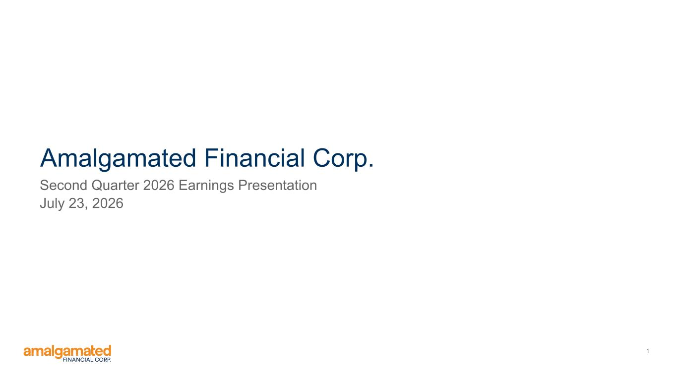
1 Amalgamated Financial Corp. Second Quarter 2026 Earnings Presentation July 23, 2026


2 Safe Harbor Statements FORWARD-LOOKING STATEMENTS Statements included in this presentation that are not historical in nature are intended to be, and are hereby identified as, forward-looking statements within the meaning of the Private Securities Litigation Reform Act, Section 21E of the Securities Exchange Act of 1934, as amended. Forward- looking statements generally can be identified through the use of forward-looking terminology such as “may,” “will,” “anticipate,” “aspire,” “should,” “would,” “believe,” “contemplate,” “expect,” “estimate,” “continue,” “in the future,” “may” and “intend,” as well as other similar words and expressions of the future. Forward-looking statements are subject to known and unknown risks, uncertainties and other factors, any or all of which could cause actual results to differ materially from the results expressed or implied by such forward-looking statements. These risks and uncertainties include, but are not limited to: 1. uncertain conditions in the banking industry and in national, regional and local economies in core markets, which may have an adverse impact on business, operations and financial performance; 2. deterioration in the financial condition of borrowers, as well as deterioration in the reputational profile of borrowers, resulting in significant increases in credit losses and provisions for those losses; 3. deposit outflows and subsequent declines in liquidity caused by factors that could include lack of confidence in the banking system, a deterioration in market conditions or the financial condition of depositors; 4. changes in deposits, including an increase in uninsured deposits; 5. ability to maintain sufficient liquidity to meet deposit and debt obligations as they come due, which may require that the Company sell investment securities at a loss, negatively impacting net income, earnings and capital; 6. unfavorable conditions in the capital markets, which may cause declines in stock price and the value of investments; 7. negative economic and political conditions that adversely affect the general economy, housing prices, the real estate market, the job market, consumer confidence, the financial condition of borrowers and consumer spending habits, which may affect, among other things, the level of non- performing assets, charge-offs and provision expense; 8. fluctuations or unanticipated changes in the interest rate environment including changes in net interest margin or changes in the yield curve that affect investments, loans or deposits; 9. the general decline in the real estate and lending markets, particularly in commercial real estate in the Company’s market areas, and the effects of the enactment of or changes to rent-control and other similar regulations on multi-family housing; 10. implementation by the current presidential administration of a regulatory reform agenda that is significantly different from that of the prior presidential administration, impacting the rule making, supervision, examination and enforcement of the banking regulation agencies; 11. changes in U.S. trade policies and other global political factors beyond the Company’s control, including the imposition of tariffs, which raise economic uncertainty, potentially leading to slower growth and a decrease in loan demand; 12. the outcome of legal or regulatory proceedings that may be instituted against us; 13. inability to achieve organic loan and deposit growth and the composition of that growth; 14. composition of the Company’s loan portfolio, including any concentration in industries or sectors that may experience unanticipated or anticipated adverse conditions greater than other industries or sectors in the national or local economies in which the Company operates; 15. inaccuracy of the assumptions and estimates the Company makes and policies that the Company implements in establishing the allowance for credit losses; 16. changes in loan underwriting, credit review or loss reserve policies associated with economic conditions, examination conclusions, or regulatory developments; 17. any matter that would cause the Company to conclude that there was impairment of any asset, including intangible assets; 18. limitations on the ability to declare and pay dividends; 19. the impact of competition with other financial institutions, including pricing pressures and the resulting impact on results, including as a result of compression to net interest margin; 20. increased competition for experienced members of the workforce including executives in the banking industry; 21. a failure in or breach of operational or security systems or infrastructure, or those of third party vendors or other service providers, including as a result of unauthorized access, computer viruses, phishing schemes, spam attacks, human error, natural disasters, power loss and other security breaches; 22. increased regulatory scrutiny and exposure from the use of “big data” techniques, machine learning, and artificial intelligence; 23. a downgrade in the Company’s credit rating; 24. “greenwashing claims” against the Company and environmental, social, and governance ("ESG") products and increased scrutiny and political opposition to ESG and diversity, equity, and inclusion ("DEI") practices; 25. any unanticipated or greater than anticipated adverse conditions (including the possibility of earthquakes, wildfires, and other natural disasters) affecting the markets in which the Company operates; 26. physical and transitional risks related to climate change as they impact the business and the businesses that the Company finances; 27. future repurchase of the Company’s shares through the Company’s common stock repurchase program; and 28. descriptions of assumptions underlying or relating to any of the foregoing. Additional factors which could affect the forward-looking statements can be found in the Company’s Annual Reports on Form 10-K, Quarterly Reports on Form 10-Q, and Current Reports on Form 8-K filed with the SEC and available on the SEC's website at https://www.sec.gov/. The Company disclaims any obligation to update or revise any forward-looking statements contained in this release, which speak only as of the date hereof, whether as a result of new information, future events or otherwise, except as required by law. NON-GAAP FINANCIAL MEASURES This presentation contains certain non-GAAP financial measures including, without limitation, “Core Operating Revenue,” “Core Non-interest Expense,” “Tangible Common Equity,” “Average Tangible Common Equity,” “Core Efficiency Ratio,” “Core Net Income,” “Core ROAA,” and “Core ROATCE.” We believe these non-GAAP financial measures provide useful information to management and investors that is supplementary to our financial condition, results of operations and cash flows computed in accordance with GAAP. Specifically, we believe these non-GAAP financial measures (a) allow management and investors to better assess our performance by removing volatility that is associated with discrete items that are unrelated to our core business, and (b) enable a more complete understanding of factors and trends affecting our business. Non-GAAP financial measures, however, have inherent limitations, are not required to be uniformly applied, and are not audited. Accordingly, these non-GAAP financial measures should not be considered as substitutes for GAAP financial measures, and we strongly encourage investors to review the GAAP financial measures included in this presentation and not to place undue reliance on any single financial measure. In addition, because non-GAAP financial measures are not standardized, it may not be possible to compare the non-GAAP financial measures presented in this presentation with other companies’ non-GAAP financial measures having the same or similar names. As such, you should not view these disclosures as a substitute for results determined in accordance with GAAP, and they are not necessarily comparable to non-GAAP financial measures that other companies use. Reconciliations of non-GAAP financial disclosures to what we believe to be the most directly comparable GAAP measures found in this presentation are set forth in the final pages of this presentation and also may be viewed on the bank’s website, amalgamatedbank.com. You should assume that all numbers presented are unaudited unless otherwise noted.

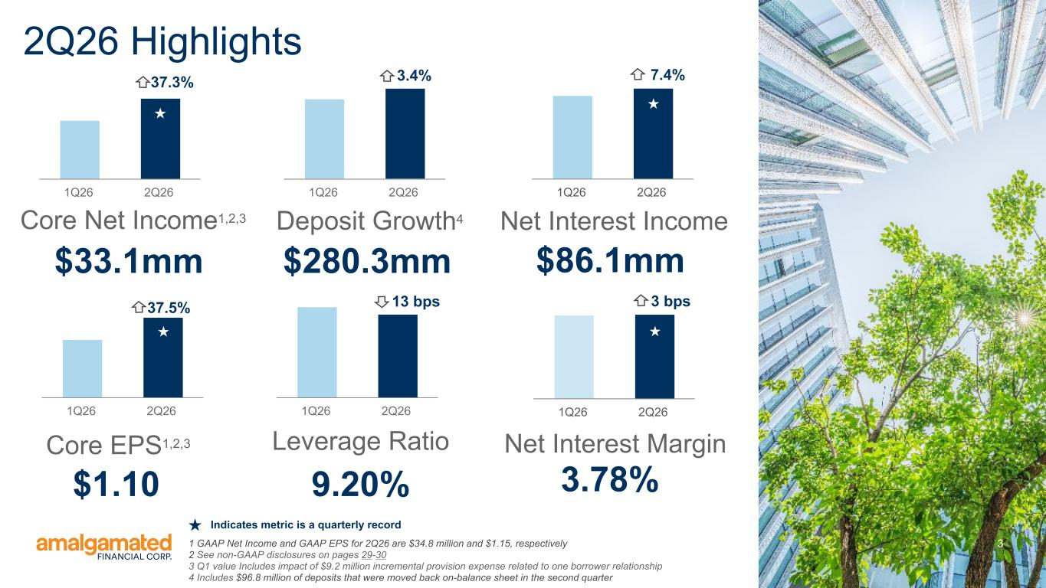
3 $33.1mm Core Net Income1,2,3 $1.10 Core EPS1,2,3 $280.3mm Deposit Growth4 9.20% Leverage Ratio $86.1mm Net Interest Income 3.78% Net Interest Margin 2Q26 Highlights 1Q26 2Q26 1Q26 2Q26 3.4% 1Q26 2Q261Q26 2Q26 1Q26 2Q26 37.3% 1Q26 2Q26 3 bps13 bps 7.4% 1 GAAP Net Income and GAAP EPS for 2Q26 are $34.8 million and $1.15, respectively 2 See non-GAAP disclosures on pages 29-30 3 Q1 value Includes impact of $9.2 million incremental provision expense related to one borrower relationship 4 Includes $96.8 million of deposits that were moved back on-balance sheet in the second quarter 37.5% Indicates metric is a quarterly record

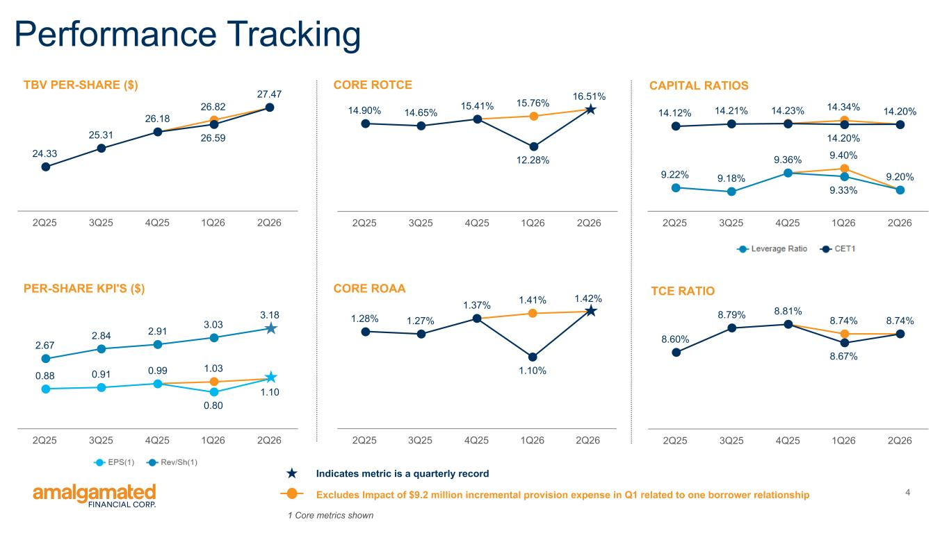
4 1.41% 1.28% 1.27% 1.37% 1.10% 1.42% 2Q25 3Q25 4Q25 1Q26 2Q26 9.40% 9.22% 9.18% 9.36% 9.33% 9.20% 14.34% 14.20%14.12% 14.21% 14.23% 14.20% 2Q25 3Q25 4Q25 1Q26 2Q26 26.82 24.33 25.31 26.18 26.59 27.47 2Q25 3Q25 4Q25 1Q26 2Q26 15.76% 14.90% 14.65% 15.41% 12.28% 16.51% 2Q25 3Q25 4Q25 1Q26 2Q26 CORE ROAAPER-SHARE KPI'S ($) TBV PER-SHARE ($) CORE ROTCE Performance Tracking 1 Core metrics shown 1.03 0.88 0.91 0.99 0.80 1.10 2.67 2.84 2.91 3.03 3.18 2Q25 3Q25 4Q25 1Q26 2Q26 CAPITAL RATIOS 8.74% 8.60% 8.79% 8.81% 8.67% 8.74% 2Q25 3Q25 4Q25 1Q26 2Q26 TCE RATIO Excludes Impact of $9.2 million incremental provision expense in Q1 related to one borrower relationship Indicates metric is a quarterly record

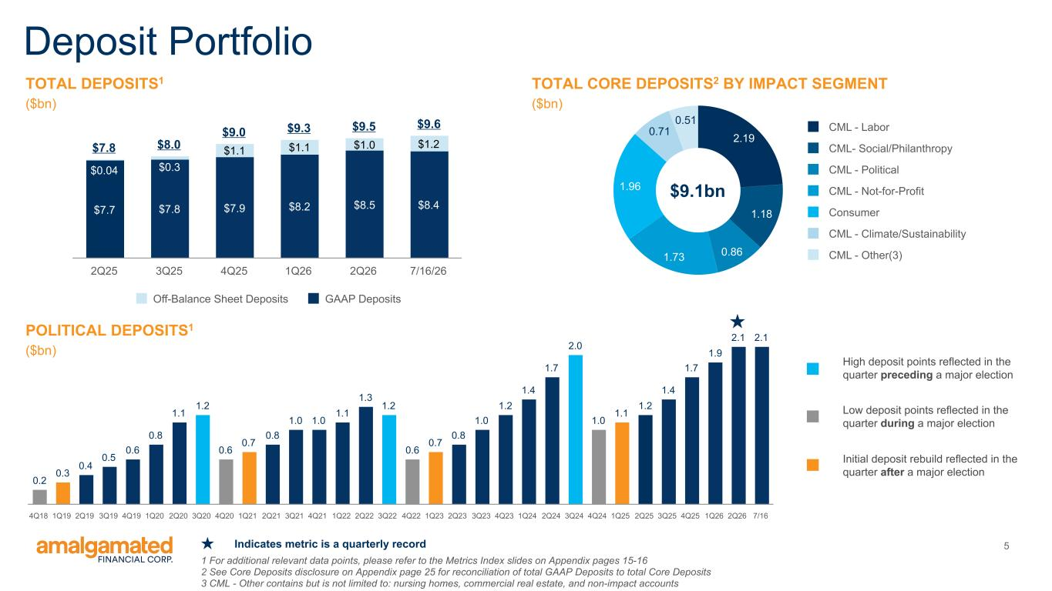
5 TOTAL DEPOSITS1 ($bn) Deposit Portfolio $7.8 $8.0 $9.0 $9.3 $9.5 $9.6 $7.7 $7.8 $7.9 $8.2 $8.5 $8.4 $0.04 $0.3 $1.1 $1.1 $1.0 $1.2 Off-Balance Sheet Deposits GAAP Deposits 2Q25 3Q25 4Q25 1Q26 2Q26 7/16/26 2.19 1.18 0.861.73 1.96 0.71 0.51 CML - Labor CML- Social/Philanthropy CML - Political CML - Not-for-Profit Consumer CML - Climate/Sustainability CML - Other(3) 1 For additional relevant data points, please refer to the Metrics Index slides on Appendix pages 15-16 2 See Core Deposits disclosure on Appendix page 25 for reconciliation of total GAAP Deposits to total Core Deposits 3 CML - Other contains but is not limited to: nursing homes, commercial real estate, and non-impact accounts TOTAL CORE DEPOSITS2 BY IMPACT SEGMENT ($bn) POLITICAL DEPOSITS1 ($bn) 0.2 0.3 0.4 0.5 0.6 0.8 1.1 1.2 0.6 0.7 0.8 1.0 1.0 1.1 1.3 1.2 0.6 0.7 0.8 1.0 1.2 1.4 1.7 2.0 1.0 1.1 1.2 1.4 1.7 1.9 2.1 2.1 4Q18 1Q19 2Q19 3Q19 4Q19 1Q20 2Q20 3Q20 4Q20 1Q21 2Q21 3Q21 4Q21 1Q22 2Q22 3Q22 4Q22 1Q23 2Q23 3Q23 4Q23 1Q24 2Q24 3Q24 4Q24 1Q25 2Q25 3Q25 4Q25 1Q26 2Q26 7/16 $9.1bn High deposit points reflected in the quarter preceding a major election Low deposit points reflected in the quarter during a major election Initial deposit rebuild reflected in the quarter after a major election Indicates metric is a quarterly record

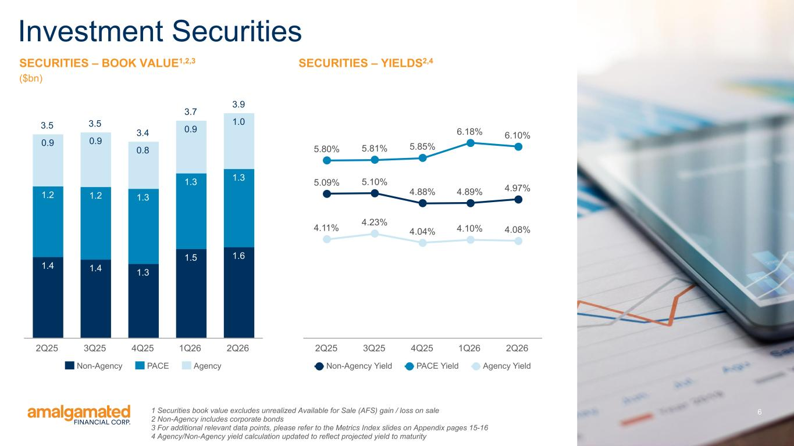
6 SECURITIES – BOOK VALUE1,2,3 ($bn) Investment Securities 3.5 3.5 3.4 3.7 3.9 1.4 1.4 1.3 1.5 1.6 1.2 1.2 1.3 1.3 1.3 0.9 0.9 0.8 0.9 1.0 Non-Agency PACE Agency 2Q25 3Q25 4Q25 1Q26 2Q26 1 Securities book value excludes unrealized Available for Sale (AFS) gain / loss on sale 2 Non-Agency includes corporate bonds 3 For additional relevant data points, please refer to the Metrics Index slides on Appendix pages 15-16 4 Agency/Non-Agency yield calculation updated to reflect projected yield to maturity SECURITIES – YIELDS2,4 5.09% 5.10% 4.88% 4.89% 4.97% 5.80% 5.81% 5.85% 6.18% 6.10% 4.11% 4.23% 4.04% 4.10% 4.08% Non-Agency Yield PACE Yield Agency Yield 2Q25 3Q25 4Q25 1Q26 2Q26

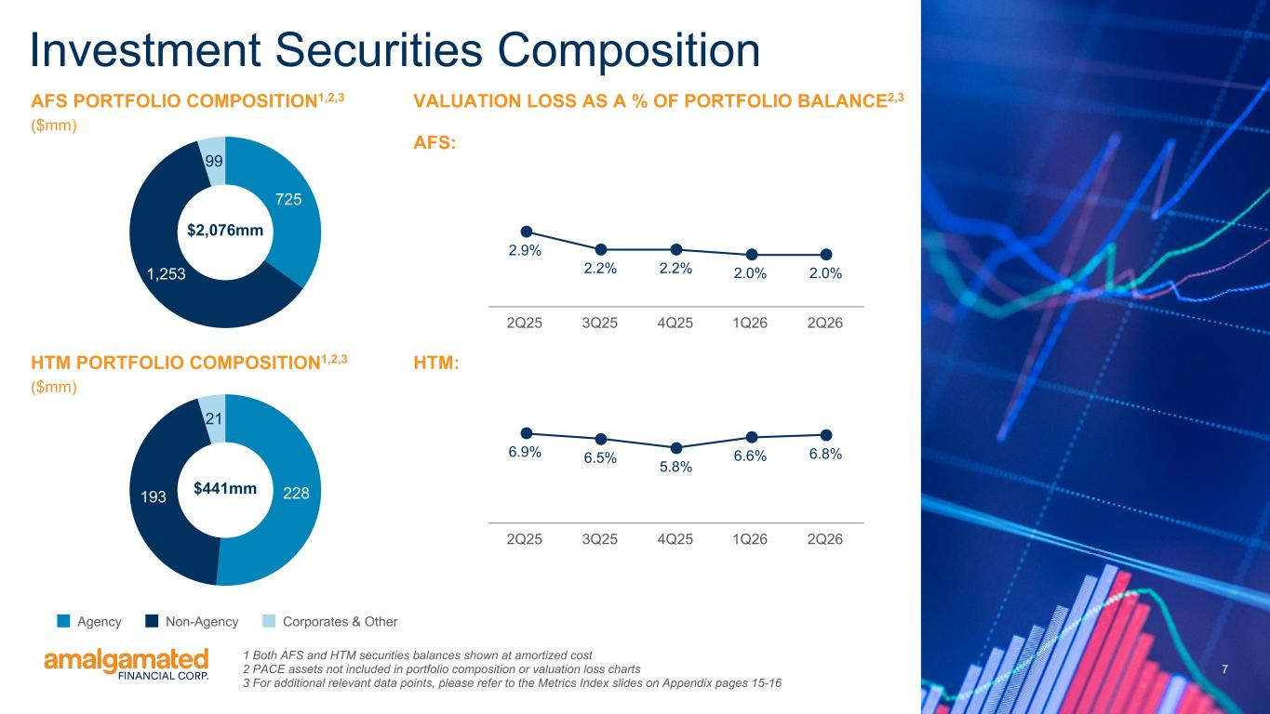
7 7 725 1,253 99 Investment Securities Composition HTM PORTFOLIO COMPOSITION1,2,3 ($mm) 228193 21 Agency Non-Agency Corporates & Other $2,076mm $441mm VALUATION LOSS AS A % OF PORTFOLIO BALANCE2,3 AFS: AFS PORTFOLIO COMPOSITION1,2,3 ($mm) 1 Both AFS and HTM securities balances shown at amortized cost 2 PACE assets not included in portfolio composition or valuation loss charts 3 For additional relevant data points, please refer to the Metrics Index slides on Appendix pages 15-16 2.9% 2.2% 2.2% 2.0% 2.0% 2Q25 3Q25 4Q25 1Q26 2Q26 6.9% 6.5% 5.8% 6.6% 6.8% 2Q25 3Q25 4Q25 1Q26 2Q26 HTM:

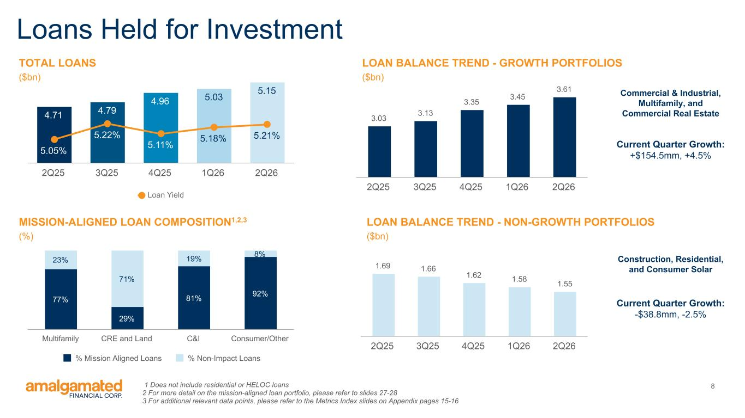
8 Loans Held for Investment TOTAL LOANS ($bn) 4.71 4.79 4.96 5.03 5.15 5.05% 5.22% 5.11% 5.18% 5.21% Loan Yield 2Q25 3Q25 4Q25 1Q26 2Q26 3.03 3.13 3.35 3.45 3.61 2Q25 3Q25 4Q25 1Q26 2Q26 LOAN BALANCE TREND - GROWTH PORTFOLIOS ($bn) 77% 29% 81% 92% 23% 71% 19% 8% % Mission Aligned Loans % Non-Impact Loans Multifamily CRE and Land C&I Consumer/Other MISSION-ALIGNED LOAN COMPOSITION1,2,3 (%) 1 Does not include residential or HELOC loans 2 For more detail on the mission-aligned loan portfolio, please refer to slides 27-28 3 For additional relevant data points, please refer to the Metrics Index slides on Appendix pages 15-16 1.69 1.66 1.62 1.58 1.55 2Q25 3Q25 4Q25 1Q26 2Q26 LOAN BALANCE TREND - NON-GROWTH PORTFOLIOS ($bn) Current Quarter Growth: +$154.5mm, +4.5% Current Quarter Growth: -$38.8mm, -2.5% Commercial & Industrial, Multifamily, and Commercial Real Estate Construction, Residential, and Consumer Solar

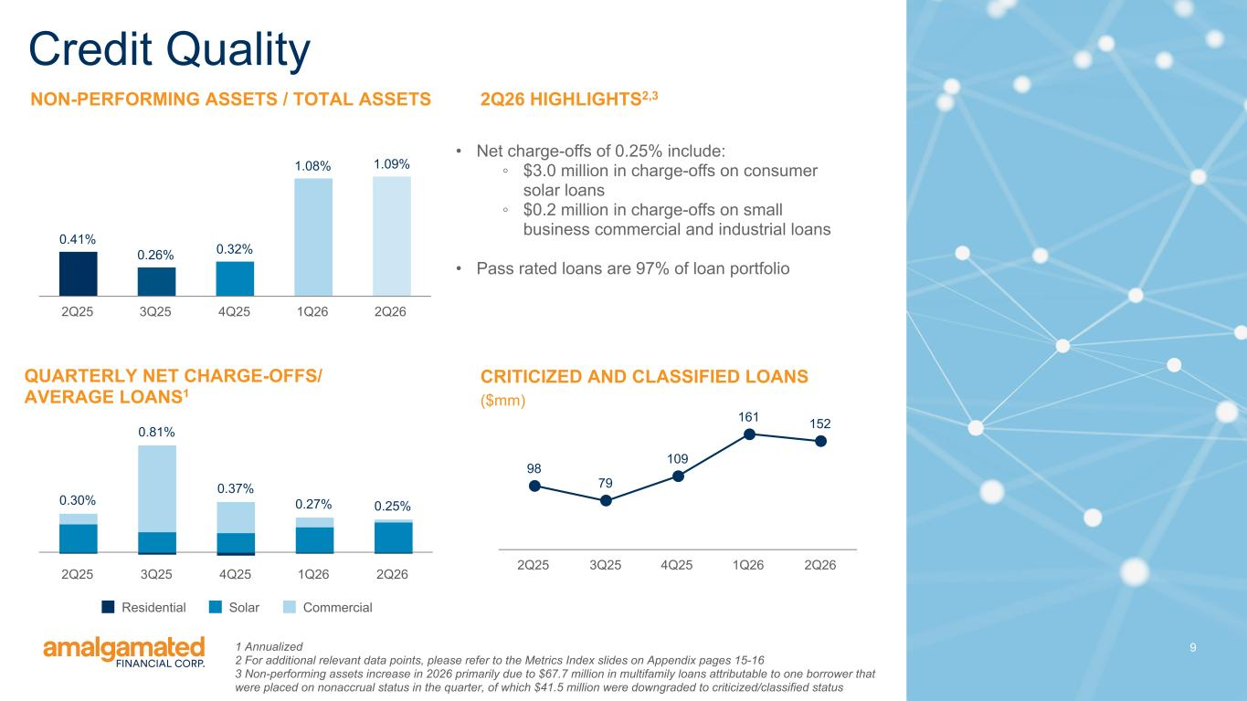
9 NON-PERFORMING ASSETS / TOTAL ASSETS Credit Quality QUARTERLY NET CHARGE-OFFS/ AVERAGE LOANS1 2Q26 HIGHLIGHTS2,3 • Net charge-offs of 0.25% include: ◦ $3.0 million in charge-offs on consumer solar loans ◦ $0.2 million in charge-offs on small business commercial and industrial loans • Pass rated loans are 97% of loan portfolio CRITICIZED AND CLASSIFIED LOANS ($mm) 0.41% 0.26% 0.32% 1.08% 1.09% 2Q25 3Q25 4Q25 1Q26 2Q26 0.30% 0.81% 0.37% 0.27% 0.25% Residential Solar Commercial 2Q25 3Q25 4Q25 1Q26 2Q26 98 79 109 161 152 2Q25 3Q25 4Q25 1Q26 2Q26 1 Annualized 2 For additional relevant data points, please refer to the Metrics Index slides on Appendix pages 15-16 3 Non-performing assets increase in 2026 primarily due to $67.7 million in multifamily loans attributable to one borrower that were placed on nonaccrual status in the quarter, of which $41.5 million were downgraded to criticized/classified status

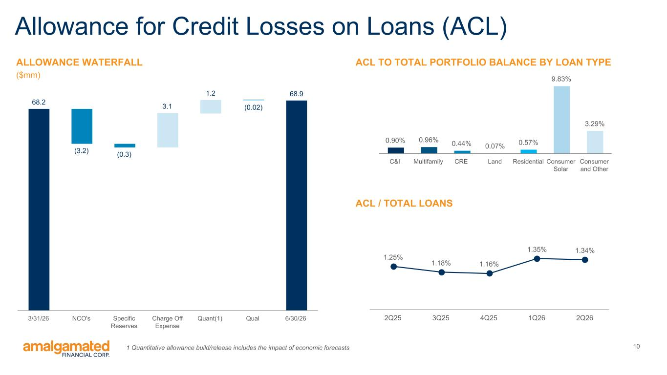
10 Allowance for Credit Losses on Loans (ACL) ACL / TOTAL LOANS 1.25% 1.18% 1.16% 1.35% 1.34% 2Q25 3Q25 4Q25 1Q26 2Q26 68.2 (3.2) (0.3) 3.1 1.2 (0.02) 68.9 3/31/26 NCO's Specific Reserves Charge Off Expense Quant(1) Qual 6/30/26 ALLOWANCE WATERFALL ($mm) 0.90% 0.96% 0.44% 0.07% 0.57% 9.83% 3.29% C&I Multifamily CRE Land Residential Consumer Solar Consumer and Other ACL TO TOTAL PORTFOLIO BALANCE BY LOAN TYPE 1 Quantitative allowance build/release includes the impact of economic forecasts

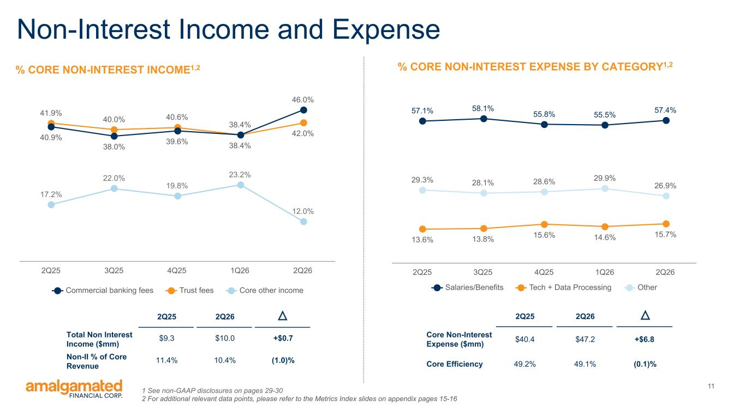
11 Non-Interest Income and Expense 17.2% 22.0% 19.8% 23.2% 12.0% 41.9% 40.0% 40.6% 38.4% 42.0%40.9% 38.0% 39.6% 38.4% 46.0% Commercial banking fees Trust fees Core other income 2Q25 3Q25 4Q25 1Q26 2Q26 % CORE NON-INTEREST INCOME1,2 1 See non-GAAP disclosures on pages 29-30 2 For additional relevant data points, please refer to the Metrics Index slides on appendix pages 15-16 57.1% 58.1% 55.8% 55.5% 57.4% 13.6% 13.8% 15.6% 14.6% 15.7% 29.3% 28.1% 28.6% 29.9% 26.9% Salaries/Benefits Tech + Data Processing Other 2Q25 3Q25 4Q25 1Q26 2Q26 % CORE NON-INTEREST EXPENSE BY CATEGORY1,2 2Q25 2Q26 Core Non-Interest Expense ($mm) $40.4 $47.2 +$6.8 Core Efficiency 49.2% 49.1% (0.1)% 2Q25 2Q26 Total Non Interest Income ($mm) $9.3 $10.0 +$0.7 Non-II % of Core Revenue 11.4% 10.4% (1.0)%

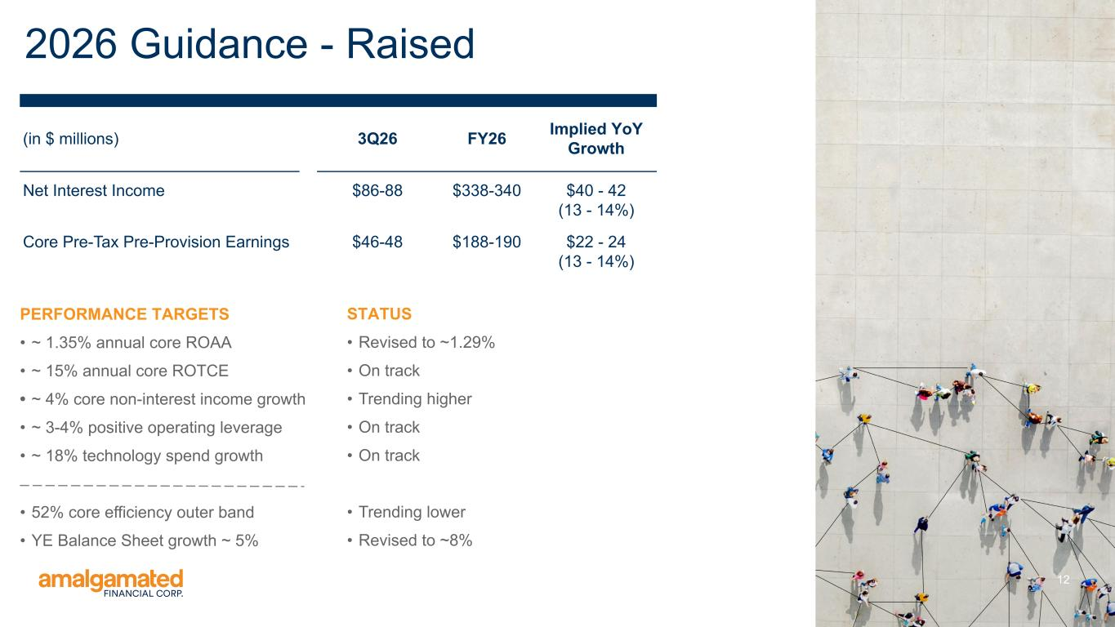
12 2026 Guidance - Raised PERFORMANCE TARGETS • ~ 1.35% annual core ROAA • ~ 15% annual core ROTCE • ~ 4% core non-interest income growth • ~ 3-4% positive operating leverage • ~ 18% technology spend growth • 52% core efficiency outer band • YE Balance Sheet growth ~ 5% (in $ millions) 3Q26 FY26 Implied YoY Growth Net Interest Income $86-88 $338-340 $40 - 42 (13 - 14%) Core Pre-Tax Pre-Provision Earnings $46-48 $188-190 $22 - 24 (13 - 14%) STATUS • Revised to ~1.29% • On track • Trending higher • On track • On track • Trending lower • Revised to ~8%

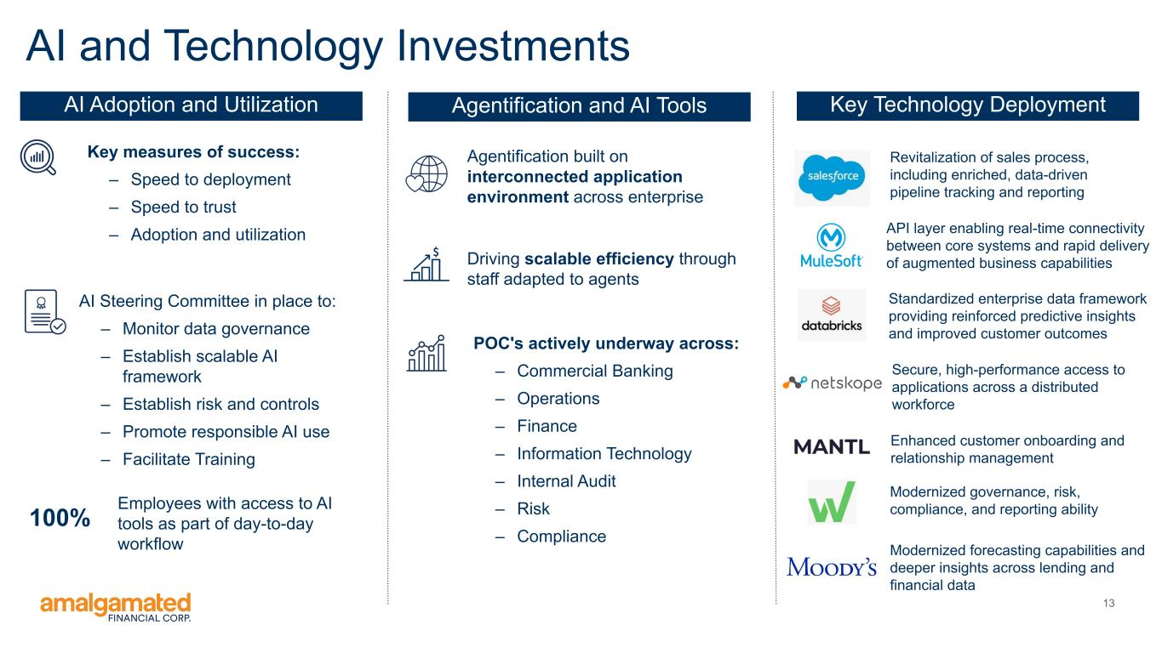
13 AI and Technology Investments AI Adoption and Utilization Agentification and AI Tools Key Technology Deployment Revitalization of sales process, including enriched, data-driven pipeline tracking and reporting Enhanced customer onboarding and relationship management Modernized governance, risk, compliance, and reporting ability Standardized enterprise data framework providing reinforced predictive insights and improved customer outcomes Employees with access to AI tools as part of day-to-day workflow 100% AI Steering Committee in place to: – Monitor data governance – Establish scalable AI framework – Establish risk and controls – Promote responsible AI use – Facilitate Training Agentification built on interconnected application environment across enterprise Key measures of success: – Speed to deployment – Speed to trust – Adoption and utilization Driving scalable efficiency through staff adapted to agents POC's actively underway across: – Commercial Banking – Operations – Finance – Information Technology – Internal Audit – Risk – Compliance Modernized forecasting capabilities and deeper insights across lending and financial data API layer enabling real-time connectivity between core systems and rapid delivery of augmented business capabilities Secure, high-performance access to applications across a distributed workforce

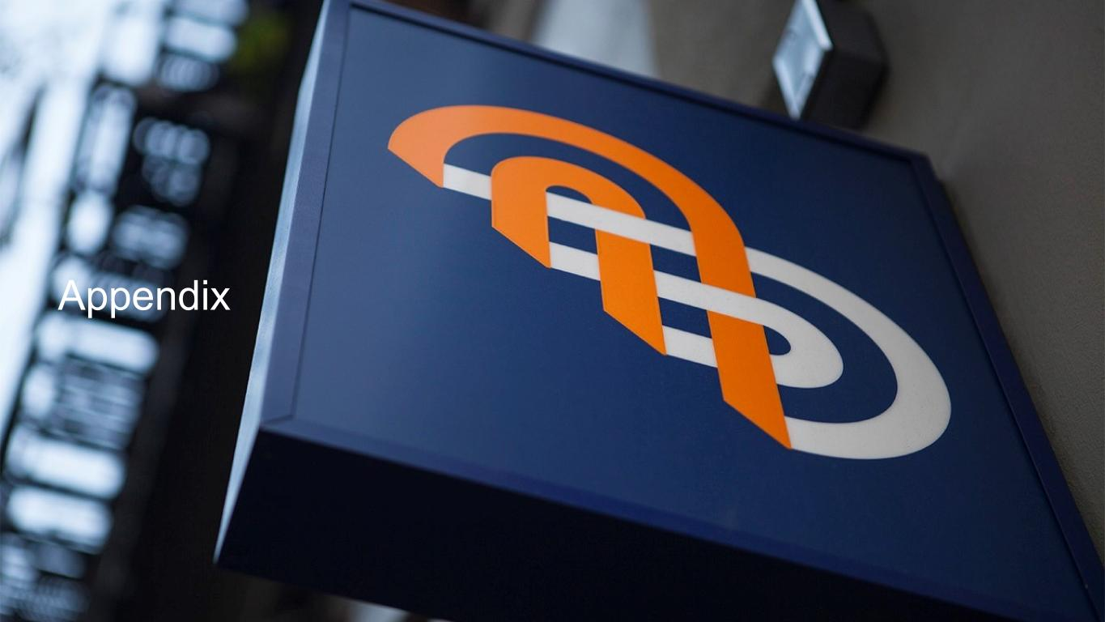
Appendix

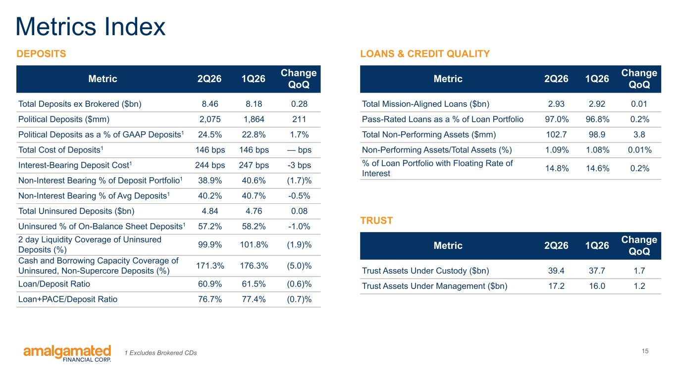
15 Metrics Index DEPOSITS Metric 2Q26 1Q26 Change QoQ Total Deposits ex Brokered ($bn) 8.46 8.18 0.28 Political Deposits ($mm) 2,075 1,864 211 Political Deposits as a % of GAAP Deposits1 24.5% 22.8% 1.7% Total Cost of Deposits1 146 bps 146 bps — bps Interest-Bearing Deposit Cost1 244 bps 247 bps -3 bps Non-Interest Bearing % of Deposit Portfolio1 38.9% 40.6% (1.7)% Non-Interest Bearing % of Avg Deposits1 40.2% 40.7% -0.5% Total Uninsured Deposits ($bn) 4.84 4.76 0.08 Uninsured % of On-Balance Sheet Deposits1 57.2% 58.2% -1.0% 2 day Liquidity Coverage of Uninsured Deposits (%) 99.9% 101.8% (1.9)% Cash and Borrowing Capacity Coverage of Uninsured, Non-Supercore Deposits (%) 171.3% 176.3% (5.0)% Loan/Deposit Ratio 60.9% 61.5% (0.6)% Loan+PACE/Deposit Ratio 76.7% 77.4% (0.7)% Metric 2Q26 1Q26 Change QoQ Total Mission-Aligned Loans ($bn) 2.93 2.92 0.01 Pass-Rated Loans as a % of Loan Portfolio 97.0% 96.8% 0.2% Total Non-Performing Assets ($mm) 102.7 98.9 3.8 Non-Performing Assets/Total Assets (%) 1.09% 1.08% 0.01% % of Loan Portfolio with Floating Rate of Interest 14.8% 14.6% 0.2% LOANS & CREDIT QUALITY Metric 2Q26 1Q26 Change QoQ Trust Assets Under Custody ($bn) 39.4 37.7 1.7 Trust Assets Under Management ($bn) 17.2 16.0 1.2 TRUST 1 Excludes Brokered CDs

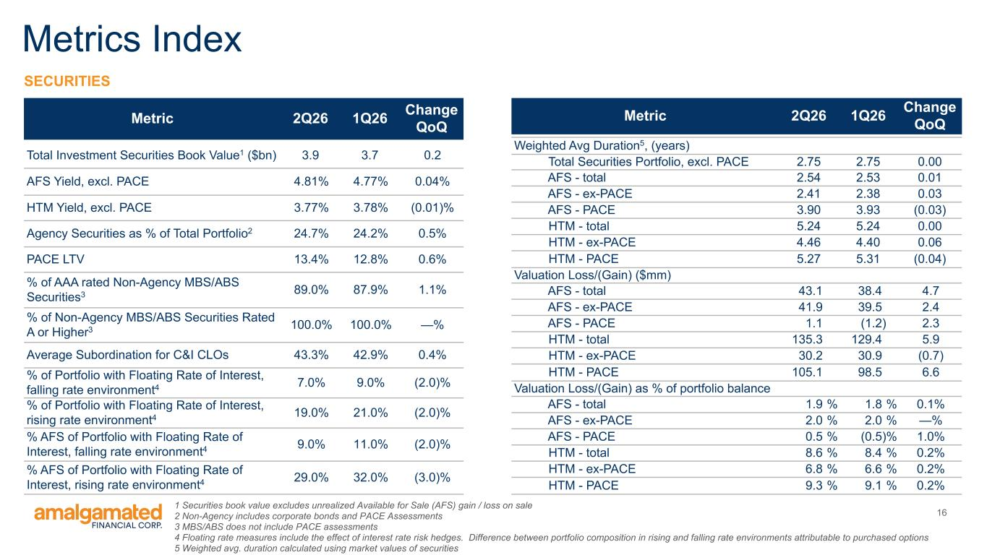
16 Metrics Index Metric 2Q26 1Q26 Change QoQ Total Investment Securities Book Value1 ($bn) 3.9 3.7 0.2 AFS Yield, excl. PACE 4.81% 4.77% 0.04% HTM Yield, excl. PACE 3.77% 3.78% (0.01)% Agency Securities as % of Total Portfolio2 24.7% 24.2% 0.5% PACE LTV 13.4% 12.8% 0.6% % of AAA rated Non-Agency MBS/ABS Securities3 89.0% 87.9% 1.1% % of Non-Agency MBS/ABS Securities Rated A or Higher3 100.0% 100.0% —% Average Subordination for C&I CLOs 43.3% 42.9% 0.4% % of Portfolio with Floating Rate of Interest, falling rate environment4 7.0% 9.0% (2.0)% % of Portfolio with Floating Rate of Interest, rising rate environment4 19.0% 21.0% (2.0)% % AFS of Portfolio with Floating Rate of Interest, falling rate environment4 9.0% 11.0% (2.0)% % AFS of Portfolio with Floating Rate of Interest, rising rate environment4 29.0% 32.0% (3.0)% SECURITIES Metric 2Q26 1Q26 Change QoQ Weighted Avg Duration5, (years) Total Securities Portfolio, excl. PACE 2.75 2.75 0.00 AFS - total 2.54 2.53 0.01 AFS - ex-PACE 2.41 2.38 0.03 AFS - PACE 3.90 3.93 (0.03) HTM - total 5.24 5.24 0.00 HTM - ex-PACE 4.46 4.40 0.06 HTM - PACE 5.27 5.31 (0.04) Valuation Loss/(Gain) ($mm) AFS - total 43.1 38.4 4.7 AFS - ex-PACE 41.9 39.5 2.4 AFS - PACE 1.1 (1.2) 2.3 HTM - total 135.3 129.4 5.9 HTM - ex-PACE 30.2 30.9 (0.7) HTM - PACE 105.1 98.5 6.6 Valuation Loss/(Gain) as % of portfolio balance AFS - total 1.9 % 1.8 % 0.1% AFS - ex-PACE 2.0 % 2.0 % —% AFS - PACE 0.5 % (0.5) % 1.0% HTM - total 8.6 % 8.4 % 0.2% HTM - ex-PACE 6.8 % 6.6 % 0.2% HTM - PACE 9.3 % 9.1 % 0.2% 1 Securities book value excludes unrealized Available for Sale (AFS) gain / loss on sale 2 Non-Agency includes corporate bonds and PACE Assessments 3 MBS/ABS does not include PACE assessments 4 Floating rate measures include the effect of interest rate risk hedges. Difference between portfolio composition in rising and falling rate environments attributable to purchased options 5 Weighted avg. duration calculated using market values of securities

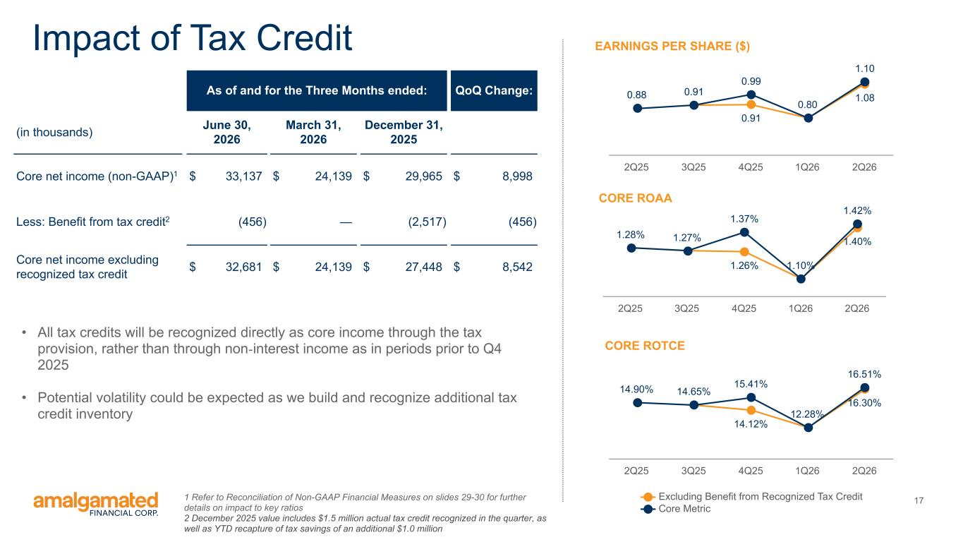
17 1.26% 1.40% 1.28% 1.27% 1.37% 1.10% 1.42% 2Q25 3Q25 4Q25 1Q26 2Q26 14.12% 16.30% 14.90% 14.65% 15.41% 12.28% 16.51% Excluding Benefit from Recognized Tax Credit Core Metric 2Q25 3Q25 4Q25 1Q26 2Q26 CORE ROAA EARNINGS PER SHARE ($)Impact of Tax Credit 1 Refer to Reconciliation of Non-GAAP Financial Measures on slides 29-30 for further details on impact to key ratios 2 December 2025 value includes $1.5 million actual tax credit recognized in the quarter, as well as YTD recapture of tax savings of an additional $1.0 million CORE ROTCE 0.88 0.91 0.91 1.08 0.99 0.80 1.10 2Q25 3Q25 4Q25 1Q26 2Q26 As of and for the Three Months ended: QoQ Change: (in thousands) June 30, 2026 March 31, 2026 December 31, 2025 Core net income (non-GAAP)1 $ 33,137 $ 24,139 $ 29,965 $ 8,998 Less: Benefit from tax credit2 (456) — (2,517) (456) Core net income excluding recognized tax credit $ 32,681 $ 24,139 $ 27,448 $ 8,542 • All tax credits will be recognized directly as core income through the tax provision, rather than through non-interest income as in periods prior to Q4 2025 • Potential volatility could be expected as we build and recognize additional tax credit inventory

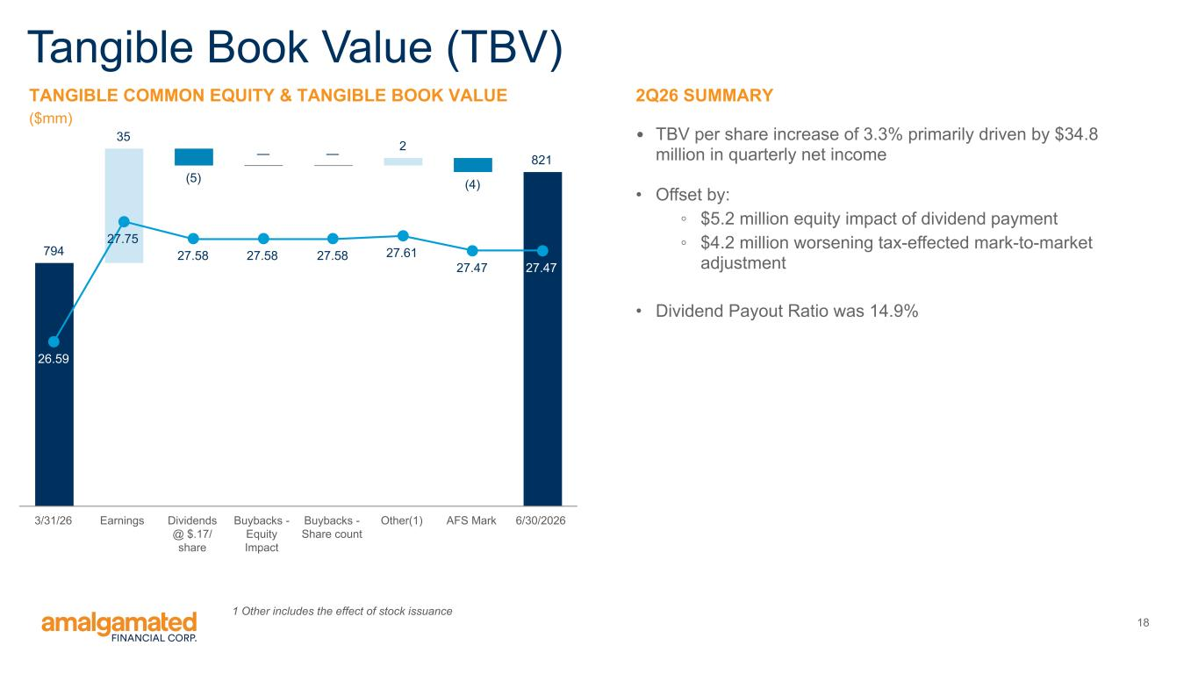
18 794 35 (5) — — 2 (4) 821 26.59 27.75 27.58 27.58 27.58 27.61 27.47 27.47 3/31/26 Earnings Dividends @ $.17/ share Buybacks - Equity Impact Buybacks - Share count Other(1) AFS Mark 6/30/2026 2Q26 SUMMARY • TBV per share increase of 3.3% primarily driven by $34.8 million in quarterly net income • Offset by: ◦ $5.2 million equity impact of dividend payment ◦ $4.2 million worsening tax-effected mark-to-market adjustment • Dividend Payout Ratio was 14.9% Tangible Book Value (TBV) TANGIBLE COMMON EQUITY & TANGIBLE BOOK VALUE ($mm) 1 Other includes the effect of stock issuance

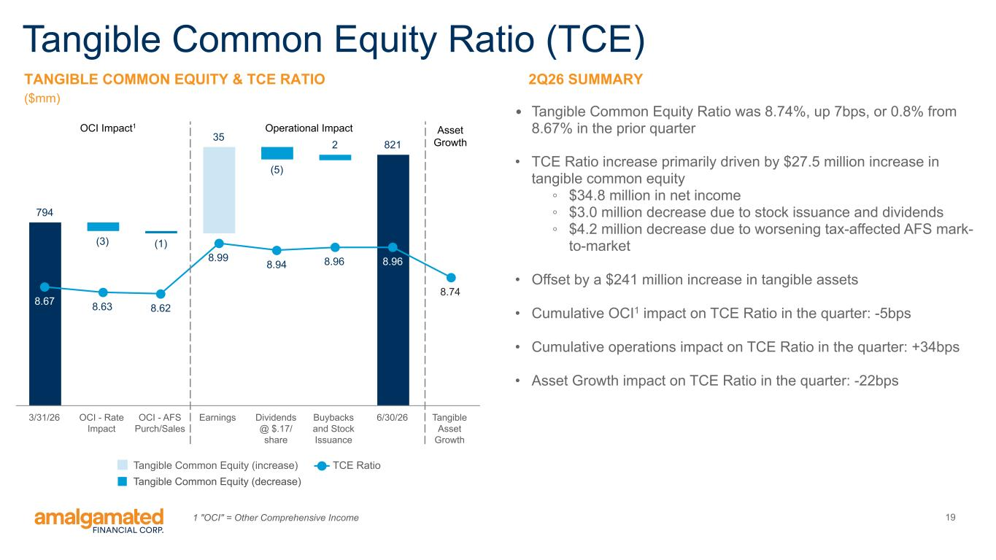
19 794 (3) (1) 35 (5) 2 821 8.67 8.63 8.62 8.99 8.94 8.96 8.96 8.74 Tangible Common Equity (increase) TCE Ratio 3/31/26 OCI - Rate Impact OCI - AFS Purch/Sales Earnings Dividends @ $.17/ share Buybacks and Stock Issuance 6/30/26 Tangible Asset Growth 2Q26 SUMMARY • Tangible Common Equity Ratio was 8.74%, up 7bps, or 0.8% from 8.67% in the prior quarter • TCE Ratio increase primarily driven by $27.5 million increase in tangible common equity ◦ $34.8 million in net income ◦ $3.0 million decrease due to stock issuance and dividends ◦ $4.2 million decrease due to worsening tax-affected AFS mark- to-market • Offset by a $241 million increase in tangible assets • Cumulative OCI1 impact on TCE Ratio in the quarter: -5bps • Cumulative operations impact on TCE Ratio in the quarter: +34bps • Asset Growth impact on TCE Ratio in the quarter: -22bps Tangible Common Equity Ratio (TCE) TANGIBLE COMMON EQUITY & TCE RATIO ($mm) Operational ImpactOCI Impact1 Asset Growth 1 "OCI" = Other Comprehensive Income Tangible Common Equity (decrease)

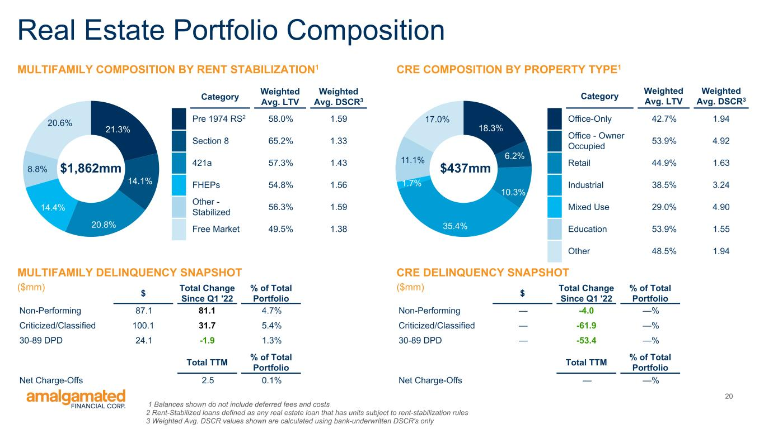
20 21.3% 14.1% 20.8% 14.4% 8.8% 20.6% Real Estate Portfolio Composition 18.3% 6.2% 10.3% 35.4% 1.7% 11.1% 17.0% CRE COMPOSITION BY PROPERTY TYPE1MULTIFAMILY COMPOSITION BY RENT STABILIZATION1 Category Weighted Avg. LTV Weighted Avg. DSCR3 Pre 1974 RS2 58.0% 1.59 Section 8 65.2% 1.33 421a 57.3% 1.43 FHEPs 54.8% 1.56 Other - Stabilized 56.3% 1.59 Free Market 49.5% 1.38 Category Weighted Avg. LTV Weighted Avg. DSCR3 Office-Only 42.7% 1.94 Office - Owner Occupied 53.9% 4.92 Retail 44.9% 1.63 Industrial 38.5% 3.24 Mixed Use 29.0% 4.90 Education 53.9% 1.55 Other 48.5% 1.94 $437mm$1,862mm MULTIFAMILY DELINQUENCY SNAPSHOT ($mm) CRE DELINQUENCY SNAPSHOT ($mm)$ Total Change Since Q1 '22 % of Total Portfolio Non-Performing 87.1 81.1 4.7% Criticized/Classified 100.1 31.7 5.4% 30-89 DPD 24.1 -1.9 1.3% Total TTM % of Total Portfolio Net Charge-Offs 2.5 0.1% $ Total Change Since Q1 '22 % of Total Portfolio Non-Performing — -4.0 —% Criticized/Classified — -61.9 —% 30-89 DPD — -53.4 —% Total TTM % of Total Portfolio Net Charge-Offs — —% 1 Balances shown do not include deferred fees and costs 2 Rent-Stabilized loans defined as any real estate loan that has units subject to rent-stabilization rules 3 Weighted Avg. DSCR values shown are calculated using bank-underwritten DSCR's only

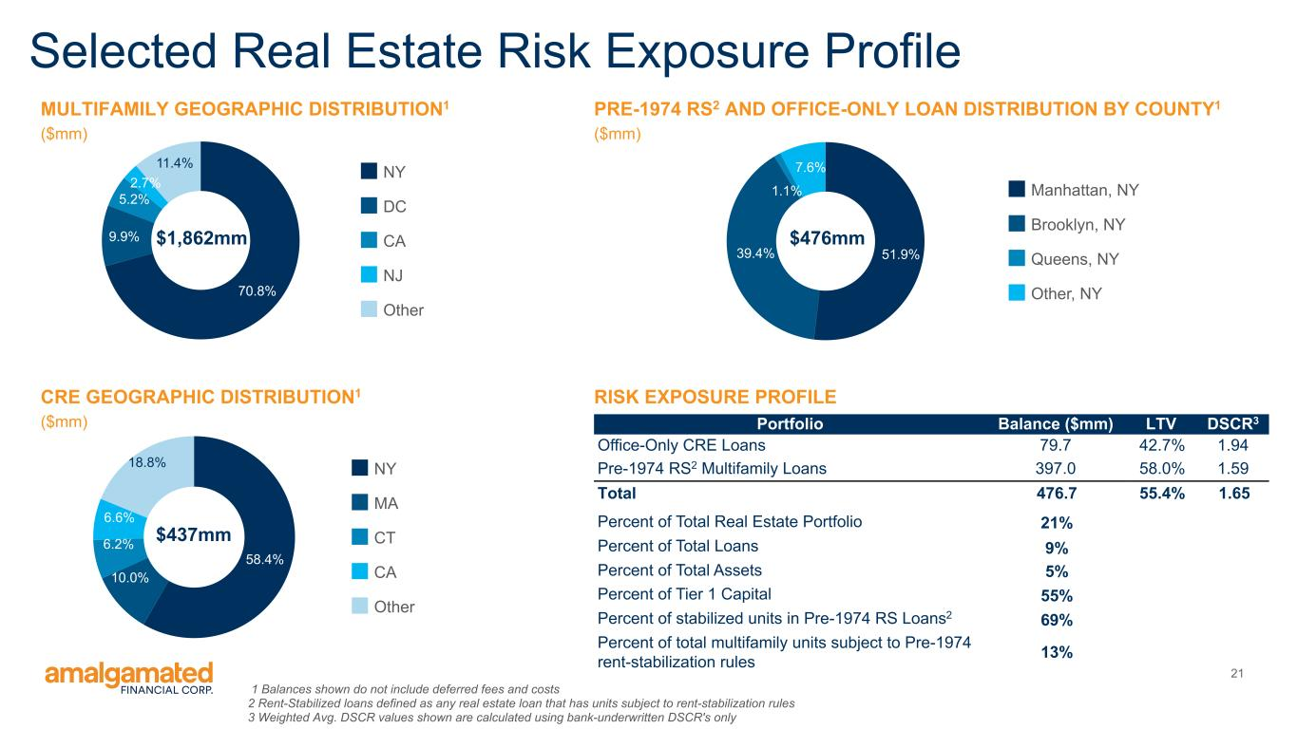
21 Selected Real Estate Risk Exposure Profile RISK EXPOSURE PROFILE PRE-1974 RS2 AND OFFICE-ONLY LOAN DISTRIBUTION BY COUNTY1 ($mm) 51.9%39.4% 1.1% 7.6% Manhattan, NY Brooklyn, NY Queens, NY Other, NY $476mm Portfolio Balance ($mm) LTV DSCR3 Office-Only CRE Loans 79.7 42.7% 1.94 Pre-1974 RS2 Multifamily Loans 397.0 58.0% 1.59 Total 476.7 55.4% 1.65 Percent of Total Real Estate Portfolio 21% Percent of Total Loans 9% Percent of Total Assets 5% Percent of Tier 1 Capital 55% Percent of stabilized units in Pre-1974 RS Loans2 69% Percent of total multifamily units subject to Pre-1974 rent-stabilization rules 13% 1 Balances shown do not include deferred fees and costs 2 Rent-Stabilized loans defined as any real estate loan that has units subject to rent-stabilization rules 3 Weighted Avg. DSCR values shown are calculated using bank-underwritten DSCR's only MULTIFAMILY GEOGRAPHIC DISTRIBUTION1 ($mm) 70.8% 9.9% 5.2% 2.7% 11.4% NY DC CA NJ Other $1,862mm CRE GEOGRAPHIC DISTRIBUTION1 ($mm) 58.4% 10.0% 6.2% 6.6% 18.8% NY MA CT CA Other $437mm

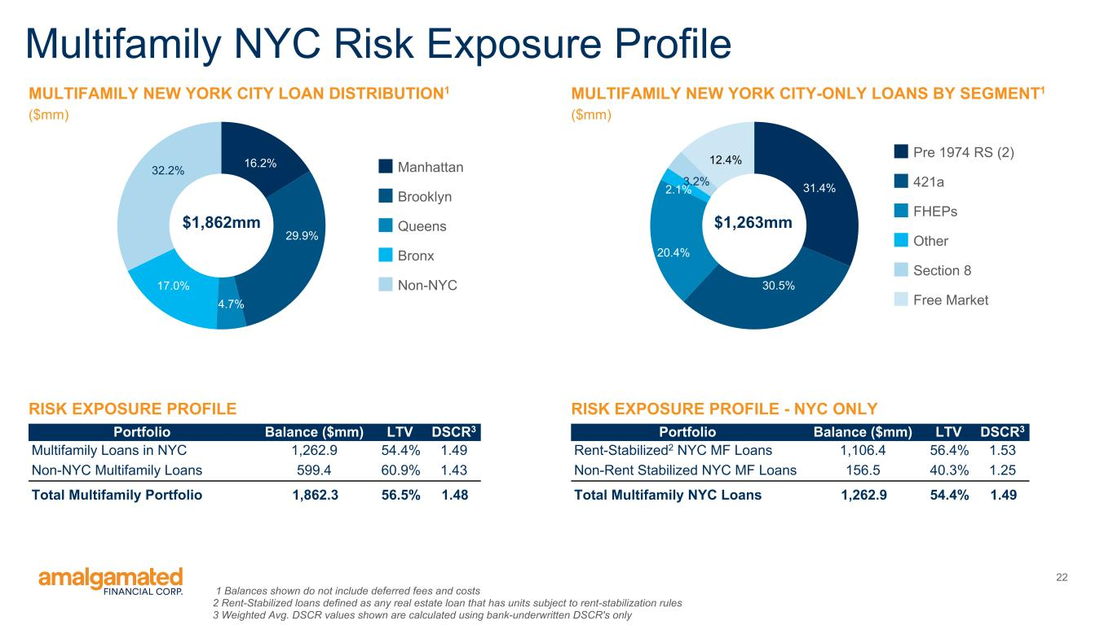
22 Multifamily NYC Risk Exposure Profile 1 Balances shown do not include deferred fees and costs 2 Rent-Stabilized loans defined as any real estate loan that has units subject to rent-stabilization rules 3 Weighted Avg. DSCR values shown are calculated using bank-underwritten DSCR's only RISK EXPOSURE PROFILE MULTIFAMILY NEW YORK CITY LOAN DISTRIBUTION1 ($mm) 16.2% 29.9% 4.7% 17.0% 32.2% Manhattan Brooklyn Queens Bronx Non-NYC $1,862mm Portfolio Balance ($mm) LTV DSCR3 Multifamily Loans in NYC 1,262.9 54.4% 1.49 Non-NYC Multifamily Loans 599.4 60.9% 1.43 Total Multifamily Portfolio 1,862.3 56.5% 1.48 RISK EXPOSURE PROFILE - NYC ONLY MULTIFAMILY NEW YORK CITY-ONLY LOANS BY SEGMENT1 ($mm) 31.4% 30.5% 20.4% 2.1% 3.2% 12.4% Pre 1974 RS (2) 421a FHEPs Other Section 8 Free Market $1,263mm Portfolio Balance ($mm) LTV DSCR3 Rent-Stabilized2 NYC MF Loans 1,106.4 56.4% 1.53 Non-Rent Stabilized NYC MF Loans 156.5 40.3% 1.25 Total Multifamily NYC Loans 1,262.9 54.4% 1.49

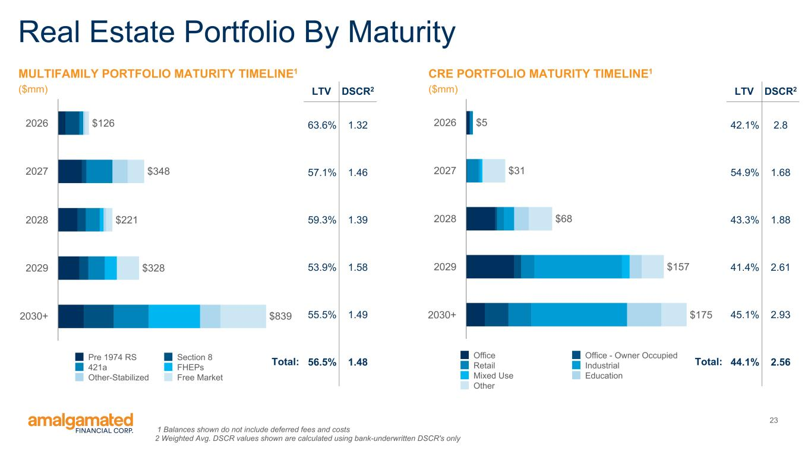
23 Real Estate Portfolio By Maturity MULTIFAMILY PORTFOLIO MATURITY TIMELINE1 ($mm) $126 $348 $221 $328 $839 Pre 1974 RS Section 8 421a FHEPs Other-Stabilized Free Market 2026 2027 2028 2029 2030+ CRE PORTFOLIO MATURITY TIMELINE1 ($mm) $5 $31 $68 $157 $175 Office Office - Owner Occupied Retail Industrial Mixed Use Education Other 2026 2027 2028 2029 2030+ LTV DSCR2 63.6% 1.32 57.1% 1.46 59.3% 1.39 53.9% 1.58 55.5% 1.49 56.5% 1.48 LTV DSCR2 42.1% 2.8 54.9% 1.68 43.3% 1.88 41.4% 2.61 45.1% 2.93 44.1% 2.56Total:Total: 1 Balances shown do not include deferred fees and costs 2 Weighted Avg. DSCR values shown are calculated using bank-underwritten DSCR's only

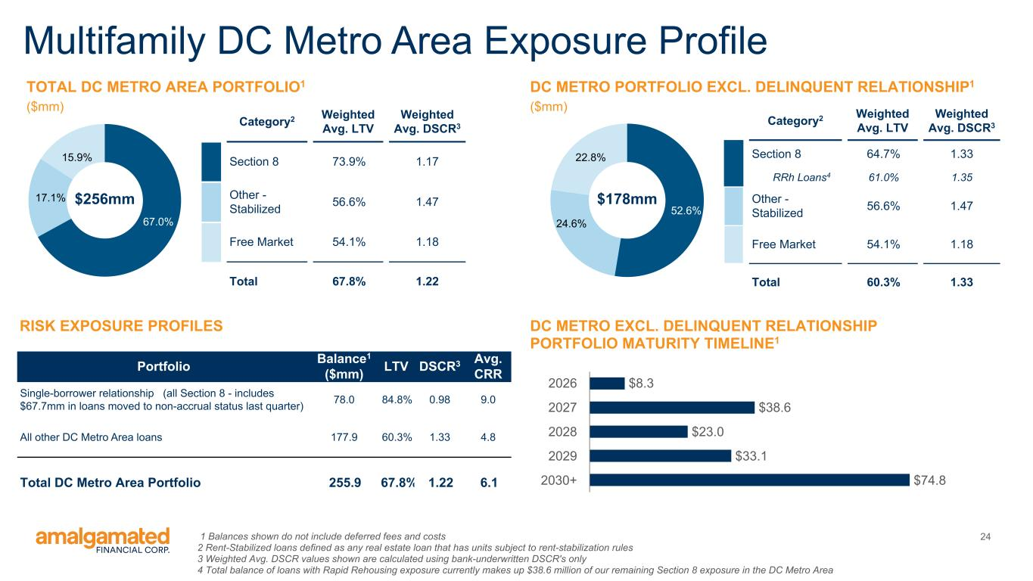
24 Multifamily DC Metro Area Exposure Profile 1 Balances shown do not include deferred fees and costs 2 Rent-Stabilized loans defined as any real estate loan that has units subject to rent-stabilization rules 3 Weighted Avg. DSCR values shown are calculated using bank-underwritten DSCR's only 4 Total balance of loans with Rapid Rehousing exposure currently makes up $38.6 million of our remaining Section 8 exposure in the DC Metro Area RISK EXPOSURE PROFILES TOTAL DC METRO AREA PORTFOLIO1 ($mm) Portfolio Balance1 ($mm) LTV DSCR3 Avg. CRR Single-borrower relationship (all Section 8 - includes $67.7mm in loans moved to non-accrual status last quarter) 78.0 84.8% 0.98 9.0 All other DC Metro Area loans 177.9 60.3% 1.33 4.8 Total DC Metro Area Portfolio 255.9 67.8% 1.22 6.1 DC METRO PORTFOLIO EXCL. DELINQUENT RELATIONSHIP1 ($mm) 67.0% 17.1% 15.9% $256mm Category2 Weighted Avg. LTV Weighted Avg. DSCR3 Section 8 73.9% 1.17 Other - Stabilized 56.6% 1.47 Free Market 54.1% 1.18 Total 67.8% 1.22 52.6% 24.6% 22.8% Category2 Weighted Avg. LTV Weighted Avg. DSCR3 Section 8 64.7% 1.33 RRh Loans4 61.0% 1.35 Other - Stabilized 56.6% 1.47 Free Market 54.1% 1.18 Total 60.3% 1.33 $178mm $8.3 $38.6 $23.0 $33.1 $74.8 2026 2027 2028 2029 2030+ DC METRO EXCL. DELINQUENT RELATIONSHIP PORTFOLIO MATURITY TIMELINE1

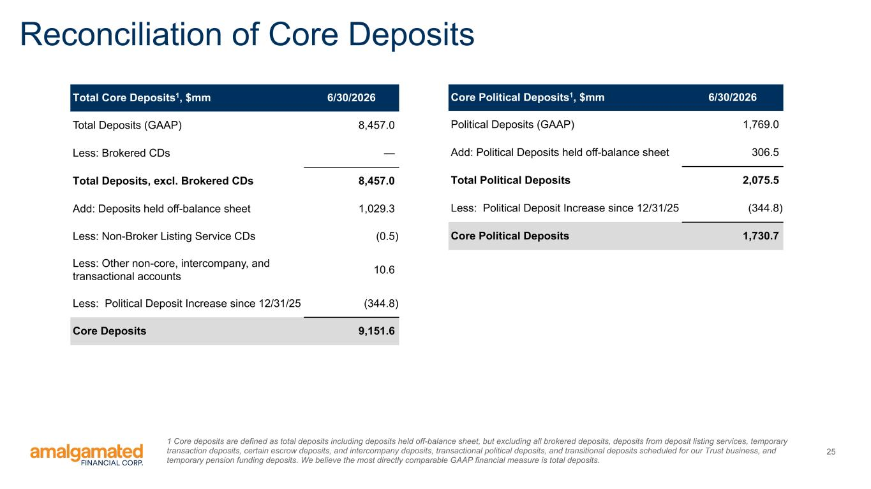
25 Reconciliation of Core Deposits Total Core Deposits1, $mm 6/30/2026 Total Deposits (GAAP) 8,457.0 Less: Brokered CDs — Total Deposits, excl. Brokered CDs 8,457.0 Add: Deposits held off-balance sheet 1,029.3 Less: Non-Broker Listing Service CDs (0.5) Less: Other non-core, intercompany, and transactional accounts 10.6 Less: Political Deposit Increase since 12/31/25 (344.8) Core Deposits 9,151.6 Core Political Deposits1, $mm 6/30/2026 Political Deposits (GAAP) 1,769.0 Add: Political Deposits held off-balance sheet 306.5 Total Political Deposits 2,075.5 Less: Political Deposit Increase since 12/31/25 (344.8) Core Political Deposits 1,730.7 1 Core deposits are defined as total deposits including deposits held off-balance sheet, but excluding all brokered deposits, deposits from deposit listing services, temporary transaction deposits, certain escrow deposits, and intercompany deposits, transactional political deposits, and transitional deposits scheduled for our Trust business, and temporary pension funding deposits. We believe the most directly comparable GAAP financial measure is total deposits.

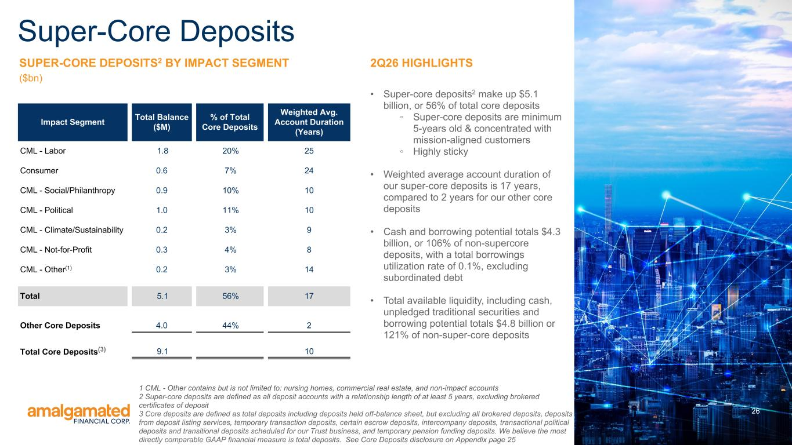
26 SUPER-CORE DEPOSITS2 BY IMPACT SEGMENT ($bn) 2Q26 HIGHLIGHTS • Super-core deposits2 make up $5.1 billion, or 56% of total core deposits ◦ Super-core deposits are minimum 5-years old & concentrated with mission-aligned customers ◦ Highly sticky • Weighted average account duration of our super-core deposits is 17 years, compared to 2 years for our other core deposits • Cash and borrowing potential totals $4.3 billion, or 106% of non-supercore deposits, with a total borrowings utilization rate of 0.1%, excluding subordinated debt • Total available liquidity, including cash, unpledged traditional securities and borrowing potential totals $4.8 billion or 121% of non-super-core deposits Impact Segment Total Balance ($M) % of Total Core Deposits Weighted Avg. Account Duration (Years) CML - Labor 1.8 20% 25 Consumer 0.6 7% 24 CML - Social/Philanthropy 0.9 10% 10 CML - Political 1.0 11% 10 CML - Climate/Sustainability 0.2 3% 9 CML - Not-for-Profit 0.3 4% 8 CML - Other(1) 0.2 3% 14 Total 5.1 56% 17 Other Core Deposits 4.0 44% 2 Total Core Deposits(3) 9.1 10 Super-Core Deposits 1 CML - Other contains but is not limited to: nursing homes, commercial real estate, and non-impact accounts 2 Super-core deposits are defined as all deposit accounts with a relationship length of at least 5 years, excluding brokered certificates of deposit 3 Core deposits are defined as total deposits including deposits held off-balance sheet, but excluding all brokered deposits, deposits from deposit listing services, temporary transaction deposits, certain escrow deposits, intercompany deposits, transactional political deposits and transitional deposits scheduled for our Trust business, and temporary pension funding deposits. We believe the most directly comparable GAAP financial measure is total deposits. See Core Deposits disclosure on Appendix page 25

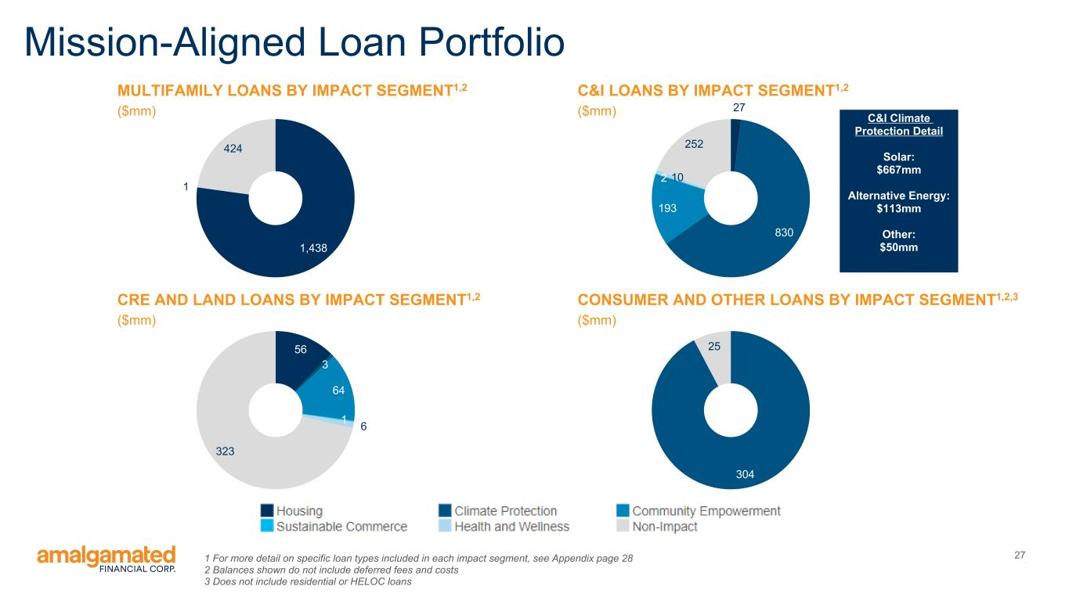
271 For more detail on specific loan types included in each impact segment, see Appendix page 28 2 Balances shown do not include deferred fees and costs 3 Does not include residential or HELOC loans Mission-Aligned Loan Portfolio 1,438 1 424 CRE AND LAND LOANS BY IMPACT SEGMENT1,2 ($mm) 56 3 64 1 6 323 C&I LOANS BY IMPACT SEGMENT1,2 ($mm) 27 830 193 2 10 252 CONSUMER AND OTHER LOANS BY IMPACT SEGMENT1,2,3 ($mm) 304 25 C&I Climate Protection Detail Solar: $667mm Alternative Energy: $113mm Other: $50mm MULTIFAMILY LOANS BY IMPACT SEGMENT1,2 ($mm)

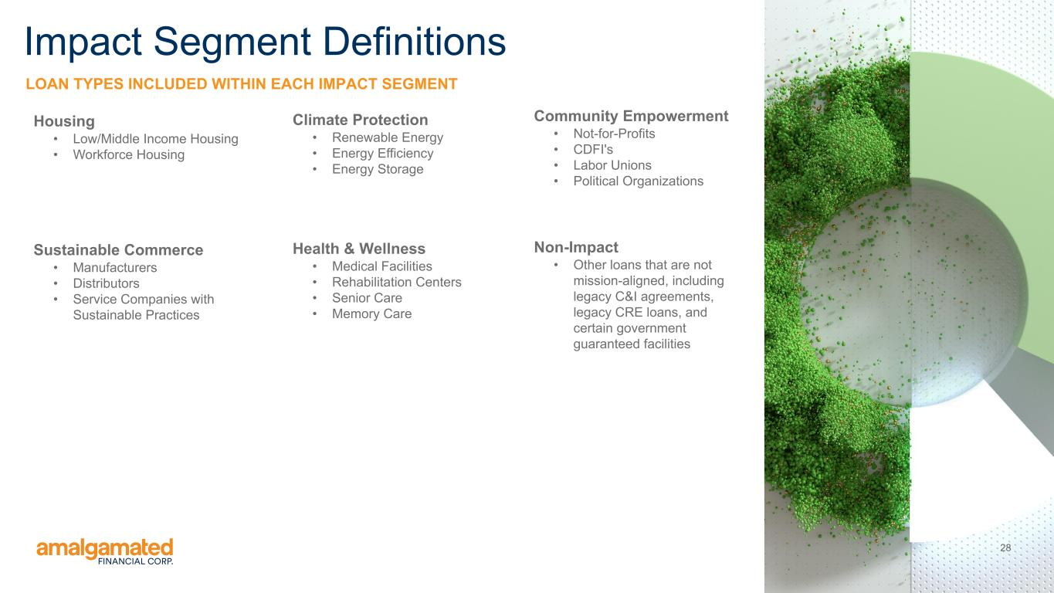
28 LOAN TYPES INCLUDED WITHIN EACH IMPACT SEGMENT Impact Segment Definitions Climate Protection • Renewable Energy • Energy Efficiency • Energy Storage Community Empowerment • Not-for-Profits • CDFI's • Labor Unions • Political Organizations Health & Wellness • Medical Facilities • Rehabilitation Centers • Senior Care • Memory Care Housing • Low/Middle Income Housing • Workforce Housing Sustainable Commerce • Manufacturers • Distributors • Service Companies with Sustainable Practices Non-Impact • Other loans that are not mission-aligned, including legacy C&I agreements, legacy CRE loans, and certain government guaranteed facilities

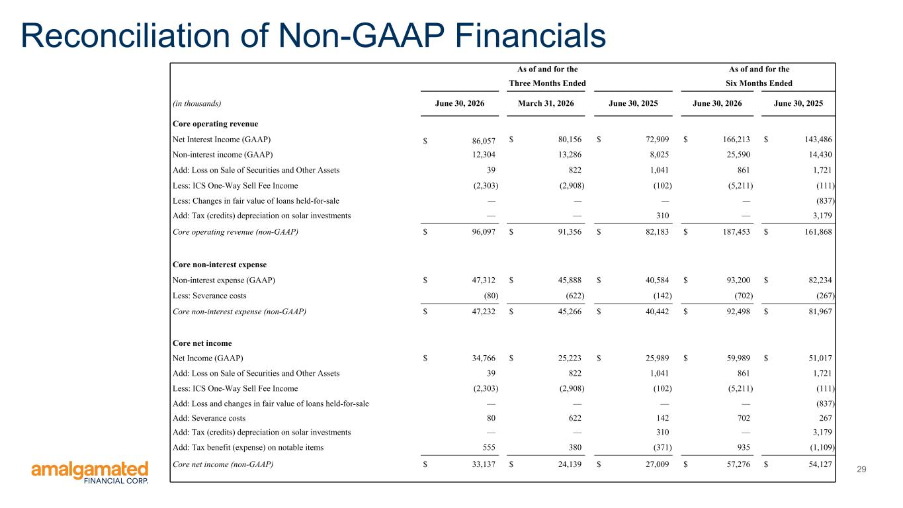
29 Reconciliation of Non-GAAP Financials As of and for the As of and for the Three Months Ended Six Months Ended (in thousands) June 30, 2026 March 31, 2026 June 30, 2025 June 30, 2026 June 30, 2025 Core operating revenue Net Interest Income (GAAP) $ 86,057 $ 80,156 $ 72,909 $ 166,213 $ 143,486 Non-interest income (GAAP) 12,304 13,286 8,025 25,590 14,430 Add: Loss on Sale of Securities and Other Assets 39 822 1,041 861 1,721 Less: ICS One-Way Sell Fee Income (2,303) (2,908) (102) (5,211) (111) Less: Changes in fair value of loans held-for-sale — — — — (837) Add: Tax (credits) depreciation on solar investments — — 310 — 3,179 Core operating revenue (non-GAAP) $ 96,097 $ 91,356 $ 82,183 $ 187,453 $ 161,868 Core non-interest expense Non-interest expense (GAAP) $ 47,312 $ 45,888 $ 40,584 $ 93,200 $ 82,234 Less: Severance costs (80) (622) (142) (702) (267) Core non-interest expense (non-GAAP) $ 47,232 $ 45,266 $ 40,442 $ 92,498 $ 81,967 Core net income Net Income (GAAP) $ 34,766 $ 25,223 $ 25,989 $ 59,989 $ 51,017 Add: Loss on Sale of Securities and Other Assets 39 822 1,041 861 1,721 Less: ICS One-Way Sell Fee Income (2,303) (2,908) (102) (5,211) (111) Add: Loss and changes in fair value of loans held-for-sale — — — — (837) Add: Severance costs 80 622 142 702 267 Add: Tax (credits) depreciation on solar investments — — 310 — 3,179 Add: Tax benefit (expense) on notable items 555 380 (371) 935 (1,109) Core net income (non-GAAP) $ 33,137 $ 24,139 $ 27,009 $ 57,276 $ 54,127

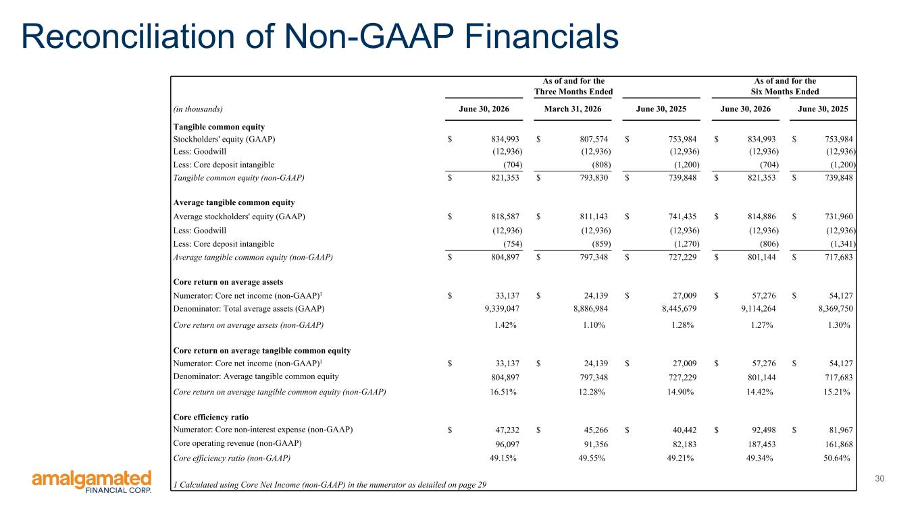
30 Reconciliation of Non-GAAP Financials As of and for the As of and for the Three Months Ended Six Months Ended (in thousands) June 30, 2026 March 31, 2026 June 30, 2025 June 30, 2026 June 30, 2025 Tangible common equity Stockholders' equity (GAAP) $ 834,993 $ 807,574 $ 753,984 $ 834,993 $ 753,984 Less: Goodwill (12,936) (12,936) (12,936) (12,936) (12,936) Less: Core deposit intangible (704) (808) (1,200) (704) (1,200) Tangible common equity (non-GAAP) $ 821,353 $ 793,830 $ 739,848 $ 821,353 $ 739,848 Average tangible common equity Average stockholders' equity (GAAP) $ 818,587 $ 811,143 $ 741,435 $ 814,886 $ 731,960 Less: Goodwill (12,936) (12,936) (12,936) (12,936) (12,936) Less: Core deposit intangible (754) (859) (1,270) (806) (1,341) Average tangible common equity (non-GAAP) $ 804,897 $ 797,348 $ 727,229 $ 801,144 $ 717,683 Core return on average assets Numerator: Core net income (non-GAAP)1 $ 33,137 $ 24,139 $ 27,009 $ 57,276 $ 54,127 Denominator: Total average assets (GAAP) 9,339,047 8,886,984 8,445,679 9,114,264 8,369,750 Core return on average assets (non-GAAP) 1.42% 1.10% 1.28% 1.27% 1.30% Core return on average tangible common equity Numerator: Core net income (non-GAAP)1 $ 33,137 $ 24,139 $ 27,009 $ 57,276 $ 54,127 Denominator: Average tangible common equity 804,897 797,348 727,229 801,144 717,683 Core return on average tangible common equity (non-GAAP) 16.51% 12.28% 14.90% 14.42% 15.21% Core efficiency ratio Numerator: Core non-interest expense (non-GAAP) $ 47,232 $ 45,266 $ 40,442 $ 92,498 $ 81,967 Core operating revenue (non-GAAP) 96,097 91,356 82,183 187,453 161,868 Core efficiency ratio (non-GAAP) 49.15% 49.55% 49.21% 49.34% 50.64% 1 Calculated using Core Net Income (non-GAAP) in the numerator as detailed on page 29


Thank You amalgamatedbank.com Member FDIC

